DEPARTMENT OF SOCIAL WELFARE AND DEVELOPMENT

NATIONAL CAPITAL REGION

BIDS & AWARDS COMMITTEE (BAC)

Bidding documents for the:

EARLY PROCUREMENT FOR THE SUPPLY AND DELIVERY OF VARIOUS MEDICINES AND MEDICAL SUPPLIES FOR CENTER/RESIDENTIAL CARE FACILITIES (C/RCFs) OF THE DEPARTMENT OF SOCIAL WELFARE AND DEVELOPMENT – NATIONAL CAPITAL REGION (DSWD-NCR) FOR THE YEAR 2023

(Invitation to Bid No. 22-11-20)

Sixth Edition
July 2020

Preface

These Philippine Bidding Documents (PBDs) for the procurement of Goods through Competitive Bidding have been prepared by the Government of the Philippines for use by any branch, constitutional commission or office, agency, department, bureau, office, or instrumentality of the Government of the Philippines, National Government Agencies, including Government-Owned and/or Controlled Corporations, Government Financing Institutions, State Universities and Colleges, and Local Government Unit. The procedures and practices presented in this document have been developed through broad experience, and are for mandatory use in projects that are financed in whole or in part by the Government of the Philippines or any foreign government/foreign or international financing institution in accordance with the provisions of the 2016 revised Implementing Rules and Regulations of Republic Act No. 9184.

The Bidding Documents shall clearly and adequately define, among others: (i) the objectives, scope, and expected outputs and/or results of the proposed contract or Framework Agreement, as the case may be; (ii) the eligibility requirements of Bidders; (iii) the expected contract or Framework Agreement duration, the estimated quantity in the case of procurement of goods, delivery schedule and/or time frame; and (iv) the obligations, duties, and/or functions of the winning bidder.

Care should be taken to check the relevance of the provisions of the PBDs against the requirements of the specific Goods to be procured. If duplication of a subject is inevitable in other sections of the document prepared by the Procuring Entity, care must be exercised to avoid contradictions between clauses dealing with the same matter.

Moreover, each section is prepared with notes intended only as information for the Procuring Entity or the person drafting the Bidding Documents. They shall not be included in the final documents. The following general directions should be observed when using the documents:

- All the documents listed in the Table of Contents are normally required for the procurement of Goods. However, they should be adapted as necessary to the circumstances of the particular Procurement Project.

- Specific details, such as the “name of the Procuring Entity” and “address for bid submission,” should be furnished in the Instructions to Bidders, Bid Data Sheet, and Special Conditions of Contract. The final documents should contain neither blank spaces nor options.

- This Preface and the footnotes or notes in italics included in the Invitation to Bid, Bid Data Sheet, General Conditions of Contract, Special Conditions of Contract, Schedule of Requirements, and Specifications are not part of the text of the final document, although they contain instructions that the Procuring Entity should strictly follow.

- The cover should be modified as required to identify the Bidding Documents as to the Procurement Project, Project Identification Number, and Procuring Entity, in addition to the date of issue.

- Modifications for specific Procurement Project details should be provided in the Special Conditions of Contract as amendments to the Conditions of Contract. For easy completion, whenever reference has to be made to specific clauses in the Bid Data Sheet or Special Conditions of Contract, these terms shall be printed in bold typeface on Sections I (Instructions to Bidders) and III (General Conditions of Contract), respectively.

- For guidelines on the use of Bidding Forms and the procurement of Foreign-Assisted Projects, these will be covered by a separate issuance of the Government Procurement Policy Board.
Table of Contents

Glossary of Acronyms, Terms, and Abbreviations 4
Section I. Invitation to Bid 7
Section II. Instructions to Bidders 10
1. Scope of Bid 11
2. Funding Information 11
3. Bidding Requirements 11
4. Corrupt, Fraudulent, Collusive, and Coercive Practices 11
5. Eligible Bidders 12
6. Origin of Goods 12
7. Subcontracts 12
8. Pre-Bid Conference 13
9. Clarification and Amendment of Bidding Documents 13
10. Documents comprising the Bid: Eligibility and Technical Components 13
11. Documents comprising the Bid: Financial Component 13
12. Bid Prices 14
13. Bid and Payment Currencies 14
14. Bid Security 15
15. Sealing and Marking of Bids 15
16. Deadline for Submission of Bids 15
17. Opening and Preliminary Examination of Bids 15
18. Domestic Preference 16
19. Detailed Evaluation and Comparison of Bids 16
20. Post-Qualification 16
21. Signing of the Contract 17
Section III. Bid Data Sheet 18
Section IV. General Conditions of Contract 22
1. Scope of Contract 23
2. Advance Payment and Terms of Payment 23
3. Performance Security 23
4. Inspection and Tests 23
5. Warranty 24
6. Liability of the Supplier 24
Section V. Special Conditions of Contract 25
Section VI. Schedule of Requirements 30
Section VII. Technical Specifications 31
Section VIII. Checklist of Technical and Financial Documents 48

Glossary of Acronyms, Terms, and Abbreviations

ABC – Approved Budget for the Contract.

BAC – Bids and Awards Committee.

Bid – A signed offer or proposal to undertake a contract submitted by a bidder in response to and in consonance with the requirements of the bidding documents. Also referred to as Proposal and Tender. (2016 revised IRR, Section 5[c])

Bidder – Refers to a contractor, manufacturer, supplier, distributor and/or consultant who submits a bid in response to the requirements of the Bidding Documents. (2016 revised IRR, Section 5[d])

Bidding Documents – The documents issued by the Procuring Entity as the bases for bids, furnishing all information necessary for a prospective bidder to prepare a bid for the Goods, Infrastructure Projects, and/or Consulting Services required by the Procuring Entity. (2016 revised IRR, Section 5[e])

BIR – Bureau of Internal Revenue.

BSP – Bangko Sentral ng Pilipinas.

Consulting Services – Refer to services for Infrastructure Projects and other types of projects or activities of the GOP requiring adequate external technical and professional expertise that are beyond the capability and/or capacity of the GOP to undertake such as, but not limited to: (i) advisory and review services; (ii) pre-investment or feasibility studies; (iii) design; (iv) construction supervision; (v) management and related services; and (vi) other technical services or special studies. (2016 revised IRR, Section 5[i])

CDA - Cooperative Development Authority.

Contract – Refers to the agreement entered into between the Procuring Entity and the Supplier or Manufacturer or Distributor or Service Provider for procurement of Goods and Services; Contractor for Procurement of Infrastructure Projects; or Consultant or Consulting Firm for Procurement of Consulting Services; as the case may be, as recorded in the Contract Form signed by the parties, including all attachments and appendices thereto and all documents incorporated by reference therein.

CIF – Cost Insurance and Freight.

CIP – Carriage and Insurance Paid.

CPI – Consumer Price Index.

DDP – Refers to the quoted price of the Goods, which means “delivered duty paid.”

DTI – Department of Trade and Industry.

EXW – Ex works.

FCA – “Free Carrier” shipping point.

FOB – “Free on Board” shipping point.

Foreign-funded Procurement or Foreign-Assisted Project– Refers to procurement whose funding source is from a foreign government, foreign or international financing institution as specified in the Treaty or International or Executive Agreement. (2016 revised IRR, Section 5[b]).
Framework Agreement – Refers to a written agreement between a procuring entity and a supplier or service provider that identifies the terms and conditions, under which specific purchases, otherwise known as “Call-Offs,” are made for the duration of the agreement. It is in the nature of an option contract between the procuring entity and the bidder(s) granting the procuring entity the option to either place an order for any of the goods or services identified in the Framework Agreement List or not buy at all, within a minimum period of one (1) year to a maximum period of three (3) years. (GPPB Resolution No. 27-2019)
GFI – Government Financial Institution.

GOCC – Government-owned and/or –controlled corporation.

Goods – Refer to all items, supplies, materials and general support services, except Consulting Services and Infrastructure Projects, which may be needed in the transaction of public businesses or in the pursuit of any government undertaking, project or activity, whether in the nature of equipment, furniture, stationery, materials for construction, or personal property of any kind, including non-personal or contractual services such as the repair and maintenance of equipment and furniture, as well as trucking, hauling, janitorial, security, and related or analogous services, as well as procurement of materials and supplies provided by the Procuring Entity for such services. The term “related” or “analogous services” shall include, but is not limited to, lease or purchase of office space, media advertisements, health maintenance services, and other services essential to the operation of the Procuring Entity. (2016 revised IRR, Section 5[r])

GOP – Government of the Philippines.

GPPB – Government Procurement Policy Board.

INCOTERMS – International Commercial Terms.

Infrastructure Projects – Include the construction, improvement, rehabilitation, demolition, repair, restoration or maintenance of roads and bridges, railways, airports, seaports, communication facilities, civil works components of information technology projects, irrigation, flood control and drainage, water supply, sanitation, sewerage and solid waste management systems, shore protection, energy/power and electrification facilities, national buildings, school buildings, hospital buildings, and other related construction projects of the government. Also referred to as civil works or works. (2016 revised IRR, Section 5[u])

LGUs – Local Government Units.

NFCC – Net Financial Contracting Capacity.

NGA – National Government Agency.

PhilGEPS - Philippine Government Electronic Procurement System.

Procurement Project – refers to a specific or identified procurement covering goods, infrastructure project or consulting services. A Procurement Project shall be described, detailed, and scheduled in the Project Procurement Management Plan prepared by the agency which shall be consolidated in the procuring entity's Annual Procurement Plan. (GPPB Circular No. 06-2019 dated 17 July 2019)

PSA – Philippine Statistics Authority.

SEC – Securities and Exchange Commission.

SLCC – Single Largest Completed Contract.

Supplier – refers to a citizen, or any corporate body or commercial company duly organized and registered under the laws where it is established, habitually established in business and engaged in the manufacture or sale of the merchandise or performance of the general services covered by his bid. (Item 3.8 of GPPB Resolution No. 13-2019, dated 23 May 2019). Supplier as used in these Bidding Documents may likewise refer to a distributor, manufacturer, contractor, or consultant.

UN – United Nations.

Section I. Invitation to Bid
INVITATION TO BID
No. 22-11-20

EARLY PROCUREMENT FOR THE SUPPLY AND DELIVERY OF VARIOUS MEDICINES AND MEDICAL SUPPLIES FOR CENTER/RESIDENTIAL CARE FACILITIES (C/RCFs) OF THE DEPARTMENT OF SOCIAL WELFARE AND DEVELOPMENT – NATIONAL CAPITAL REGION (DSWD-NCR) FOR THE YEAR 2023

- The Department of Social Welfare and Development – National Capital Region through the authorized CY 2023 National Expenditure Program (NEP) intends to apply the sum of EIGHTEEN MILLION SIXTY-NINE THOUSAND NINE HUNDRED FIFTY-FOUR PESOS AND 33/100 (Php18,069,954.33) being the Approved Budget for the Contract (ABC) to payments under the contract for each lot with following breakdown as follows:

LOT 1: Various Medicines
Contract Amount: Php17,214,436.76

LOT 2: Medical Supplies
Contract Amount: Php855,517.57

Bids received in excess of the ABC for EACH LOT shall be automatically rejected at bid opening. Late bids shall not be accepted.

- The DSWD-NCR now invites bids for the Early Procurement for the Supply and Delivery of Various Medicines and Medical Supplies for Center/Residential Care Facilities (C/RCFs) of the Department of Social Welfare and Development – National Capital Region (DSWD-NCR) for the Year 2023. Delivery of Goods and Services shall be in accordance with Section VI. Schedule of Requirements. Bidders should have completed within the last three (3) years from the date of submission and receipt of bids, a contract similar to the project. The description of an eligible bidder is contained in the Bidding Documents, particularly, in Section II. Instruction to Bidders.

- Bidding will be conducted through open competitive bidding procedures using non-discretionary pass/fail criteria as specified in the 2016 Revised Implementing Rules and Regulations (IRR) of Republic Act 9184 (R.A. 9184), otherwise known as the “Government Procurement Reform Act”.

Bidding is restricted to Filipino citizens/sole proprietorships, organizations with at least sixty percent (60%) interest or outstanding capital stock belonging to citizens of the Philippines, and to citizens or organizations of a country, the laws or regulations of which grant similar rights or privileges to Filipino citizens, pursuant to RA 5183.

- Prospective bidders may obtain further information from DSWD-NCR Bids and Awards Committee (BAC) Secretariat and inspect the Bidding Documents at the address given below from Monday to Friday at 8:00AM to 5:00PM.

- A complete set of Bidding Documents may be purchased by interested Bidders from 14 November 2022 to 7 December 2022; (November 14 to December 6, 2022; 8:00AM to 4:00PM) (December 7, 2022: until 8:30 A.M. only) from given address and website below and upon payment of the applicable fee for the Bidding Documents, pursuant to the latest Guidelines issued by the GPPB, in the amount based on the ABC per LOT. The DSWD-NCR shall allow the bidder to present its proof of payment for the fees in person.

Lot No. | Particulars | Approved Budget for the Contract (ABC) | Cost of Bidding Documents (Php)
1 | Various Medicines | Php17,214,436.76 | Php25,000.00
2 | Medical Supplies | Php855,517.57 | Php1,000.00

- The DSWD-NCR BAC will hold a Pre-Bidding Conference on 22 November 2022; 9:00 A.M. and through video conferencing via google meet (meet.google.com/tob-kozz-fqe) which shall be opened to all interested bidders.

- Bids must be received by the BAC Secretariat through manual submission as indicated below on or before 7 December 2022, 8:45 A.M. at BAC Secretariat Office, Room 301, 389 San Rafael St. cor. Legarda St. Sampaloc, Manila. Late bids shall not be accepted.

- All Bids must be accompanied by a bid security in any of the acceptable forms and in the amount stated in ITB Clause 14.

- Bid opening shall immediately follow after the deadline of the submission and receipt of bids shall be on 7 December 2022, 9:00 A.M. at DSWD-NCR-Karunungan Conference Room, 389 San Rafael St. cor. Legarda St. Sampaloc, Manila. Bids will be opened in the presence of the Bidder’s representatives who choose to attend.

- The DSWD-NCR reserves the right to accept or reject any and all bids, declare a failure of bidding, or not award the contract at any time prior to contract award in accordance with Section 35.6 and 41 of RA 9184 and its 2016 Revised Implementing Rules and Regulation (IRR), without thereby incurring any liability to the affected bidder or bidders.

- For further information, please refer to:

THE CHAIRPERSON
Bids and Awards Committee
DSWD-NCR
c/o BAC Secretariat
Room 301, DSWD-NCR Field Office
389 San Rafael St. cor. Legarda St.
Sampaloc, Manila
Email Address: dswdncr.bac@gmail.com
Telephone No.: 5310-1434

- You may visit the following websites:

For downloading of Bidding Documents: www.philgeps.gov.ph and www.ncr.dswd.gov.ph

Issued this 11th day of November 2022.

ATTY. MICHAEL JOSEPH J. LORICO
Chairperson
Bids and Awards Committee

Section II. Instructions to Bidders

Scope of Bid

The Procuring Entity, Department of Social Welfare and Development – National Capital Region (DSWD-NCR) wishes to receive Bids for the Early Procurement for the Supply and Delivery of Various Medicines and Medical Supplies for Center/Residential Care Facilities (C/RCFs) of the Department of Social Welfare and Development – National Capital Region (DSWD-NCR) for the Year 2023 with identification number ITB No. 22-11-20.

The Procurement Project (referred to herein as “Project”) is composed of Two (2) LOTS, the details of which are described in Section VII (Technical Specifications).

Funding Information

- The GOP through the source of funding as indicated below for authorized FY2023 National Expenditure Program (NEP) in the amount of EIGHTEEN MILLION SIXTY-NINE THOUSAND NINE HUNDRED FIFTY-FOUR PESOS AND 33/100 (Php18,069,954.33) being the Approved Budget for the Contract (ABC) to payments under the contract for each lot with following breakdown as follows:

LOT 1: Various Medicines
Contract Amount: Php17,214,436.76

LOT 2: Medical Supplies
Contract Amount: Php855,517.57

- The source of funding is authorized FY2023 National Expenditure Program (NEP).

Bidding Requirements

The Bidding for the Project shall be governed by all the provisions of RA No. 9184 and its 2016 revised IRR, including its Generic Procurement Manuals and associated policies, rules and regulations as the primary source thereof, while the herein clauses shall serve as the secondary source thereof.

Any amendments made to the IRR and other GPPB issuances shall be applicable only to the ongoing posting, advertisement, or IB by the BAC through the issuance of a supplemental or bid bulletin.

The Bidder, by the act of submitting its Bid, shall be deemed to have verified and accepted the general requirements of this Project, including other factors that may affect the cost, duration and execution or implementation of the contract, project, or work and examine all instructions, forms, terms, and project requirements in the Bidding Documents.

Corrupt, Fraudulent, Collusive, and Coercive Practices

The Procuring Entity, as well as the Bidders and Suppliers, shall observe the highest standard of ethics during the procurement and execution of the contract. They or through an agent shall not engage in corrupt, fraudulent, collusive, coercive, and obstructive practices defined under Annex “I” of the 2016 revised IRR of RA No. 9184 or other integrity violations in competing for the Project.

Eligible Bidders

5.1. Only Bids of Bidders found to be legally, technically, and financially capable will be evaluated.

5.2. [Select one, delete other/s]

- Foreign ownership exceeding those allowed under the rules may participate pursuant to:

    - When a Treaty or International or Executive Agreement as provided in Section 4 of the RA No. 9184 and its 2016 revised IRR allow foreign bidders to participate;

    - Citizens, corporations, or associations of a country, included in the list issued by the GPPB, the laws or regulations of which grant reciprocal rights or privileges to citizens, corporations, or associations of the Philippines;

    - When the Goods sought to be procured are not available from local suppliers; or

    - When there is a need to prevent situations that defeat competition or restrain trade.

- Foreign ownership limited to those allowed under the rules may participate in this Project.

5.3. Pursuant to Section 23.4.1.3 of the 2016 revised IRR of RA No.9184, the Bidder shall have an SLCC that is at least one (1) contract similar to the Project the value of which, adjusted to current prices using the PSA’s CPI, must be at least equivalent to:

For the procurement of Expendable Supplies: The Bidder must have completed a single contract that is similar to this Project, equivalent to at least twenty-five percent (25%) of the ABC.

5.4. The Bidders shall comply with the eligibility criteria under Section 23.4.1 of the 2016 IRR of RA No. 9184.

Origin of Goods

There is no restriction on the origin of goods other than those prohibited by a decision of the UN Security Council taken under Chapter VII of the Charter of the UN, subject to Domestic Preference requirements under ITB Clause 18.

Subcontracts

    - Subcontracting is not allowed.

    - Subcontracting of any portion of the Project does not relieve the Supplier of any liability or obligation under the Contract. The Supplier will be responsible for the acts, defaults, and negligence of any subcontractor, its agents, servants, or workmen as fully as if these were the Supplier’s own acts, defaults, or negligence, or those of its agents, servants, or workmen.

Pre-Bid Conference

The Procuring Entity will hold a pre-bid conference for this Project on the specified date and time and either at its physical address [as specified in the ITB] and/or through videoconferencing/webcasting} as indicated in paragraph 6 of the IB.

Clarification and Amendment of Bidding Documents

Prospective bidders may request for clarification on and/or interpretation of any part of the Bidding Documents. Such requests must be in writing and received by the Procuring Entity, either at its given address or through electronic mail indicated in the IB, at least ten (10) calendar days before the deadline set for the submission and receipt of Bids.

Documents comprising the Bid: Eligibility and Technical Components

    - The first envelope shall contain the eligibility and technical documents of the Bid as specified in Section VIII (Checklist of Technical and Financial Documents).

    - The Bidder’s SLCC as indicated in ITB Clause 5.3 should have been completed within the last three (3) years prior to the deadline for the submission and receipt of bids.

    - If the eligibility requirements or statements, the bids, and all other documents for submission to the BAC are in foreign language other than English, it must be accompanied by a translation in English, which shall be authenticated by the appropriate Philippine foreign service establishment, post, or the equivalent office having jurisdiction over the foreign bidder’s affairs in the Philippines. Similar to the required authentication above, for Contracting Parties to the Apostille Convention, only the translated documents shall be authenticated through an apostille pursuant to GPPB Resolution No. 13-2019 dated 23 May 2019. The English translation shall govern, for purposes of interpretation of the bid.

Documents comprising the Bid: Financial Component

  - The second bid envelope shall contain the financial documents for the Bid as specified in Section VIII (Checklist of Technical and Financial Documents).

  - If the Bidder claims preference as a Domestic Bidder or Domestic Entity, a certification issued by DTI shall be provided by the Bidder in accordance with Section 43.1.3 of the 2016 revised IRR of RA No. 9184.

  - Any bid exceeding the ABC indicated in paragraph 1 of the IB shall not be accepted.

  - For Foreign-funded Procurement, a ceiling may be applied to bid prices provided the conditions are met under Section 31.2 of the 2016 revised IRR of RA No. 9184.

Bid Prices

12.1. Prices indicated on the Price Schedule shall be entered separately in the following manner:

      - For Goods offered from within the Procuring Entity’s country:

- The price of the Goods quoted EXW (ex-works, ex-factory, ex-warehouse, ex-showroom, or off-the-shelf, as applicable);

- The cost of all customs duties and sales and other taxes already paid or payable;

- The cost of transportation, insurance, and other costs incidental to delivery of the Goods to their final destination; and

- The price of other (incidental) services, if any, listed in e.

      - For Goods offered from abroad:

- Unless otherwise stated in the BDS, the price of the Goods shall be quoted delivered duty paid (DDP) with the place of destination in the Philippines as specified in the BDS. In quoting the price, the Bidder shall be free to use transportation through carriers registered in any eligible country. Similarly, the Bidder may obtain insurance services from any eligible source country.

- The price of other (incidental) services, if any, as listed in Section VII (Technical Specifications).

Bid and Payment Currencies

    - For Goods that the Bidder will supply from outside the Philippines, the bid prices may be quoted in the local currency or tradeable currency accepted by the BSP at the discretion of the Bidder. However, for purposes of bid evaluation, Bids denominated in foreign currencies, shall be converted to Philippine currency based on the exchange rate as published in the BSP reference rate bulletin on the day of the bid opening.

    - Payment of the contract price shall be made in in Philippine Peso.

Bid Security

  - The Bidder shall submit a Bid Securing Declaration or any form of Bid Security in the amount indicated in the BDS, which shall be not less than the percentage of the ABC in accordance with the schedule in the BDS.

  - The Bid and bid security shall be valid until One Hundred Twenty (120) Calendar Days from the date of Opening of Bids. Any Bid not accompanied by an acceptable bid security shall be rejected by the Procuring Entity as non-responsive.

Sealing and Marking of Bids

Each Bidder shall submit one copy of the first and second components of its Bid.

The Procuring Entity may request additional hard copies and/or electronic copies of the Bid. However, failure of the Bidders to comply with the said request shall not be a ground for disqualification.

If the Procuring Entity allows the submission of bids through online submission or any other electronic means, the Bidder shall submit an electronic copy of its Bid, which must be digitally signed. An electronic copy that cannot be opened or is corrupted shall be considered non-responsive and, thus, automatically disqualified.

Deadline for Submission of Bids

16.1. The Bidders shall submit on the specified date and time and either at its physical address or through online submission as indicated in paragraph 7 of the IB.

Opening and Preliminary Examination of Bids

  - The BAC shall open the Bids in public at the time, on the date, and at the place specified in paragraph 9 of the IB. The Bidders’ representatives who are present shall sign a register evidencing their attendance. In case videoconferencing, webcasting or other similar technologies will be used, attendance of participants shall likewise be recorded by the BAC Secretariat.

In case the Bids cannot be opened as scheduled due to justifiable reasons, the rescheduling requirements under Section 29 of the 2016 revised IRR of RA No. 9184 shall prevail.

  - The preliminary examination of bids shall be governed by Section 30 of the 2016 revised IRR of RA No. 9184.

Domestic Preference

18.1. The Procuring Entity will grant a margin of preference for the purpose of comparison of Bids in accordance with Section 43.1.2 of the 2016 revised IRR of RA No. 9184.

Detailed Evaluation and Comparison of Bids

  - The Procuring BAC shall immediately conduct a detailed evaluation of all Bids rated “passed,” using non-discretionary pass/fail criteria. The BAC shall consider the conditions in the evaluation of Bids under Section 32.2 of the 2016 revised IRR of RA No. 9184.

  - If the Project allows partial bids, bidders may submit a proposal on any of the lots or items, and evaluation will be undertaken on a per lot or item basis, as the case maybe. In this case, the Bid Security as required by ITB Clause 15 shall be submitted for each lot or item separately.

  - The descriptions of the lots or items shall be indicated in Section VII (Technical Specifications), although the ABCs of these lots or items are indicated in the BDS for purposes of the NFCC computation pursuant to Section 23.4.2.6 of the 2016 revised IRR of RA No. 9184. The NFCC must be sufficient for the total of the ABCs for all the lots or items participated in by the prospective Bidder.

  - The Project shall be awarded as follows:

One Project having several items group into several lots, which shall be awarded as separate contracts per lot.

  - Except for bidders submitting a committed Line of Credit from a Universal or Commercial Bank in lieu of its NFCC computation, all Bids must include the NFCC computation pursuant to Section 23.4.1.4 of the 2016 revised IRR of RA No. 9184, which must be sufficient for the total of the ABCs for all the lots or items participated in by the prospective Bidder. For bidders submitting the committed Line of Credit, it must be at least equal to ten percent (10%) of the ABCs for all the lots or items participated in by the prospective Bidder.

Post-Qualification

20.2. Within a non-extendible period of five (5) calendar days from receipt by the Bidder of the notice from the BAC that it submitted the Lowest Calculated Bid, the Bidder shall submit its latest income and business tax returns filed and paid through the BIR Electronic Filing and Payment System (eFPS) and other appropriate licenses and permits required by law and stated in the BDS.

Signing of the Contract

21.1. The documents required in Section 37.2 of the 2016 revised IRR of RA No. 9184 shall form part of the Contract. Additional Contract documents are indicated in the BDS.

Section III. Bid Data Sheet

Bid Data Sheet
ITB Clause
5.3 | For this purpose, contracts similar to the Project shall be:  - Lot 1 - Supply and Delivery of Various Medicines.  - Lot 2 – Supply and Delivery of Medical Supplies.  - completed within the last three (3) years prior to the deadline for the submission and receipt of bids.
7.1 | Subcontracting is not allowed.
12 | The price of the Goods shall be quoted DDP and VAT inclusive
14.1 | The bid security shall be in the form of a Bid Securing Declaration, or any of the following forms and amounts:
 | - The amount of not less than two percent (2%) of ABC of the lot which a bidder opts to bid, if bid security is in cash, cashier’s/manager’s check, bank draft/guarantee or irrevocable letter of credit; or
 | - The amount of not less than five percent (5%) of ABC of the lot which a bidder opts to bid if bid security is in Surety Bond.
19.3 | The total ABC is EIGHTEEN MILLION SIXTY-NINE THOUSAND NINE HUNDRED FIFTY-FOUR PESOS AND 33/100 (Php18,069,954.33) being the Approved Budget for the Contract (ABC) to payments under the contract for each lot with following breakdown as follows:  LOT 1: Various Medicines  Contract Amount: Php17,214,436.76  LOT 2: Medical Supplies  Contract Amount: Php855,517.57
20.2 | Within a non-extendible period of five (5) calendar days from receipt by the supplier of the Notice of Post Qualification from the BAC that the supplier has the Lowest Calculated Bid (LCB) or Single Calculated Bid (SCB), the Supplier shall submit and/or present the following requirements for Post Qualification in accordance to Section 34 of the 2016 Revised Implementing Rules and Regulations (IRR) of RA9184:  1. Present original copy and submit a certified true copy of the following:  - Latest Income Tax Return and Business Tax Return  - Latest Value Added Tax (VAT) Return  Only tax returns filed and taxes paid through the BIR Electronic Filing & Payment System (EFPS) shall be accepted.  - The Supplier’s Audited Financial Statements for the year 2021 and 2020 (in comparative or separate form)  - Independent Auditor’s Report:  - Balance Sheet (Statement of Financial Position); and  - Income Statement (Statement of Comprehensive Income)  Each of the above statements must have stamped “received” by Bureau of Internal Revenue (BIR) or its duly accredited institutions.  - Valid Registration Certificate from Securities and Exchange Commission (SEC) for corporations, or from Department of Trade and Industry (DTI) for sole proprietorship, or from Cooperative Development Authority (CDA) for cooperatives;  - Valid Business/Mayor’s permit issued by the city or municipality where the principal place of business of the bidder is located;  - Valid Tax Clearance per EO 398, Series of 2005, as finally reviewed and approved by the BIR;  - Bureau of Internal Revenue (BIR) Registration Certificate.  - Valid and current Certificate Product Registration (CPR) or Valid Extension issued by Philippine Food and Drug Administration (PFDA)  - Valid and current License to Operate (LTO) for drug suppliers, distributors and traders issued by the Philippine Food and Drug Administration (PFDA).  - The bidder shall submit any of the following whichever is applicable:  - If the bidder is a manufacturer, certificate that the bidder manufactures the products/item; or  - If the bidder is an Exclusive/Authorized Distributor or Dealer of the products/items, Certificate or Contract from the manufacturer or importer must be provided as proof that the bidders is an Exclusive/Authorized Distributor or Dealer of the products/items; or  - If the bidder is an agent of the exclusive distributor or dealer, the following must be provided:  - Certificate or Distributor/Dealership Agreement by the Manufacturer with the distributor or dealer; and  - Contract between the distributor/dealer and the bidder.  - Copy of Contracts or PO’s, Notice of Award (NOA) and Notice to Proceed (NTP) for all On-going contracts per submitted Annex II  - Company profile and Organizational Chart. Company printed brochure may be included.  - Vicinity Map/Location of the business.  - Other appropriate licenses and permits required by law and stated in the Bidding Documents.  For joint venture:  - All Class A Documents (Legal Documents) of the Joint Venture Partner shall remain as post qualification requirements to be submitted in accordance with Section 34 of the 2016 Revised IRR of RA 9184 and ITB Clause 20.2 (a) of Bid Data Sheet of the Bidding Documents.  Failure to submit any of the post-qualification requirements on time, or a finding against the veracity thereof, shall disqualify the bidder for award. Provided in the event that a finding against the veracity of any of the documents submitted is made, it shall cause the forfeiture of the bid security in accordance with Section 69 of the IRR of RA 9184.  NOTE: FOR POST QUALIFICATION PURPOSES ONLY
20.3 | Each Bidder shall submit the following in one (1) “mother” envelope duly sealed and labeled, containing two (2) sets of envelopes:  First envelope containing three (3) sets of Eligibility and Technical documents duly sealed and marked as Original Copy, Copy One and Copy Two.  Second envelope containing three (3) sets of Financial Bid documents duly sealed and marked as Original Copy, Copy One and Copy Two.  ***See Annex IV-A,IV-B & IV-C
20.4 | All envelopes shall be labeled/marked as follows:  TO : ATTY. MICHAEL JOSEPH J. LORICO  CHAIRPERSON  BIDS AND AWARDS COMMITTEE  DSWD-NCR  FROM :_______________________________  (Name of Bidder in Capital Letters)  ADDRESS: _______________________________  (Address of Bidder in Capital Letters)  PROJECT: EARLY PROCUREMENT FOR THE SUPPLY AND DELIVERY OF VARIOUS MEDICINES AND MEDICAL SUPPLIES FOR CENTER/RESIDENTIAL CARE FACILITIES (C/RCFs) OF THE DEPARTMENT OF SOCIAL WELFARE AND DEVELOPMENT – NATIONAL CAPITAL REGION (DSWD-NCR) FOR THE YEAR 2023  BID REF NO.: ITB NO. 22-11-20  ABC : Php18,069,954.33  DO NOT OPEN BEFORE: 7 DECEMBER 2022; 9:00 A.M.

Section IV. General Conditions of Contract

Scope of Contract

This Contract shall include all such items, although not specifically mentioned, that can be reasonably inferred as being required for its completion as if such items were expressly mentioned herein. All the provisions of RA No. 9184 and its 2016 revised IRR, including the Generic Procurement Manual, and associated issuances, constitute the primary source for the terms and conditions of the Contract, and thus, applicable in contract implementation. Herein clauses shall serve as the secondary source for the terms and conditions of the Contract.

This is without prejudice to Sections 74.1 and 74.2 of the 2016 revised IRR of RA No. 9184 allowing the GPPB to amend the IRR, which shall be applied to all procurement activities, the advertisement, posting, or invitation of which were issued after the effectivity of the said amendment.

Additional requirements for the completion of this Contract shall be provided in the Special Conditions of Contract (SCC).

Advance Payment and Terms of Payment

  - Advance payment of the contract amount is provided under Annex “D” of the revised 2016 IRR of RA No. 9184.

  - The Procuring Entity is allowed to determine the terms of payment on the partial or staggered delivery of the Goods procured, provided such partial payment shall correspond to the value of the goods delivered and accepted in accordance with prevailing accounting and auditing rules and regulations. The terms of payment are indicated in the SCC.

Performance Security

Within ten (10) calendar days from receipt of the Notice of Award by the Bidder from the Procuring Entity but in no case later than prior to the signing of the Contract by both parties, the successful Bidder shall furnish the performance security in any of the forms prescribed in Section 39 of the 2016 revised IRR of RA No. 9184.

Inspection and Tests

The Procuring Entity or its representative shall have the right to inspect and/or to test the Goods to confirm their conformity to the Project specifications at no extra cost to the Procuring Entity in accordance with the Generic Procurement Manual. In addition to tests in the SCC, Section IV (Technical Specifications) shall specify what inspections and/or tests the Procuring Entity requires, and where they are to be conducted. The Procuring Entity shall notify the Supplier in writing, in a timely manner, of the identity of any representatives retained for these purposes.

All reasonable facilities and assistance for the inspection and testing of Goods, including access to drawings and production data, shall be provided by the Supplier to the authorized inspectors at no charge to the Procuring Entity.

Warranty

  - In order to assure that manufacturing defects shall be corrected by the Supplier, a warranty shall be required from the Supplier as provided under Section 62.1 of the 2016 revised IRR of RA No. 9184.

  - The Procuring Entity shall promptly notify the Supplier in writing of any claims arising under this warranty. Upon receipt of such notice, the Supplier shall, repair or replace the defective Goods or parts thereof without cost to the Procuring Entity, pursuant to the Generic Procurement Manual.

Liability of the Supplier

The Supplier’s liability under this Contract shall be as provided by the laws of the Republic of the Philippines.

If the Supplier is a joint venture, all partners to the joint venture shall be jointly and severally liable to the Procuring Entity.\

Section V. Special Conditions of Contract

Special Conditions of Contract
GCC Clause
 | Delivery and Documents –
 | For purposes of the Contract, “EXW,” “FOB,” “FCA,” “CIF,” “CIP,” “DDP” and other trade terms used to describe the obligations of the parties shall have the meanings assigned to them by the current edition of INCOTERMS published by the International Chamber of Commerce, Paris. The Delivery terms of this Contract shall be as follows:
 | [For Goods supplied from abroad, state:] “The delivery terms applicable to the Contract are DDP delivered [indicate place of destination]. In accordance with INCOTERMS.”
 | [For Goods supplied from within the Philippines, state:] “The delivery terms applicable to this Contract are delivered [indicate place of destination]. Risk and title will pass from the Supplier to the Procuring Entity upon receipt and final acceptance of the Goods at their final destination.”
 | Delivery of the Goods shall be made by the Supplier in accordance with the terms specified in Section VI (Schedule of Requirements).
 | For purposes of this Clause the Procuring Entity’s Representative at the Project Site is [indicate name(s)].
 | Incidental Services –
 | The Supplier is required to provide all of the following services, including additional services, if any, specified in Section VI. Schedule of Requirements:
 | Select appropriate requirements and delete the rest.
 | - performance or supervision of on-site assembly and/or start-up of the supplied Goods;
 | - furnishing of tools required for assembly and/or maintenance of the supplied Goods;
 | - furnishing of a detailed operations and maintenance manual for each appropriate unit of the supplied Goods;
 | - performance or supervision or maintenance and/or repair of the supplied Goods, for a period of time agreed by the parties, provided that this service shall not relieve the Supplier of any warranty obligations under this Contract; and
 | - training of the Procuring Entity’s personnel, at the Supplier’s plant and/or on-site, in assembly, start-up, operation, maintenance, and/or repair of the supplied Goods.
 | - [Specify additional incidental service requirements, as needed.]
 | The Contract price for the Goods shall include the prices charged by the Supplier for incidental services and shall not exceed the prevailing rates charged to other parties by the Supplier for similar services.
 | Spare Parts –
 | The Supplier is required to provide all of the following materials, notifications, and information pertaining to spare parts manufactured or distributed by the Supplier:
 | Select appropriate requirements and delete the rest.
 | - such spare parts as the Procuring Entity may elect to purchase from the Supplier, provided that this election shall not relieve the Supplier of any warranty obligations under this Contract; and
 | - in the event of termination of production of the spare parts:
 | - advance notification to the Procuring Entity of the pending termination, in sufficient time to permit the Procuring Entity to procure needed requirements; and
 | - following such termination, furnishing at no cost to the Procuring Entity, the blueprints, drawings, and specifications of the spare parts, if requested.
 | The spare parts and other components required are listed in Section VI (Schedule of Requirements) and the cost thereof are included in the contract price.
 | The Supplier shall carry sufficient inventories to assure ex-stock supply of consumable spare parts or components for the Goods for a period of [indicate here the time period specified. If not used indicate a time period of three times the warranty period].
 | Spare parts or components shall be supplied as promptly as possible, but in any case, within [insert appropriate time period] months of placing the order.
Packaging –

The Supplier shall provide such packaging of the Goods as is required to prevent their damage or deterioration during transit to their final destination, as indicated in this Contract. The packaging shall be sufficient to withstand, without limitation, rough handling during transit and exposure to extreme temperatures, salt and precipitation during transit, and open storage. Packaging case size and weights shall take into consideration, where appropriate, the remoteness of the Goods’ final destination and the absence of heavy handling facilities at all points in transit.
 | The packaging, marking, and documentation within and outside the packages shall comply strictly with such special requirements as shall be expressly provided for in the Contract, including additional requirements, if any, specified below, and in any subsequent instructions ordered by the Procuring Entity.
 | The outer packaging must be clearly marked on at least four (4) sides as follows:
 | Name of the Procuring Entity
 | Name of the Supplier
 | Contract Description
 | Final Destination
 | Gross weight
 | Any special lifting instructions
 | Any special handling instructions
 | Any relevant HAZCHEM classifications
 | A packaging list identifying the contents and quantities of the package is to be placed on an accessible point of the outer packaging if practical. If not practical the packaging list is to be placed inside the outer packaging but outside the secondary packaging.
 | Transportation –
 | Where the Supplier is required under Contract to deliver the Goods CIF, CIP, or DDP, transport of the Goods to the port of destination or such other named place of destination in the Philippines, as shall be specified in this Contract, shall be arranged and paid for by the Supplier, and the cost thereof shall be included in the Contract Price.
 | Where the Supplier is required under this Contract to transport the Goods to a specified place of destination within the Philippines, defined as the Project Site, transport to such place of destination in the Philippines, including insurance and storage, as shall be specified in this Contract, shall be arranged by the Supplier, and related costs shall be included in the contract price.
 | Where the Supplier is required under Contract to deliver the Goods CIF, CIP or DDP, Goods are to be transported on carriers of Philippine registry. In the event that no carrier of Philippine registry is available, Goods may be shipped by a carrier which is not of Philippine registry provided that the Supplier obtains and presents to the Procuring Entity certification to this effect from the nearest Philippine consulate to the port of dispatch. In the event that carriers of Philippine registry are available but their schedule delays the Supplier in its performance of this Contract the period from when the Goods were first ready for shipment and the actual date of shipment the period of delay will be considered force majeure.
 | The Procuring Entity accepts no liability for the damage of Goods during transit other than those prescribed by INCOTERMS for DDP deliveries. In the case of Goods supplied from within the Philippines or supplied by domestic Suppliers risk and title will not be deemed to have passed to the Procuring Entity until their receipt and final acceptance at the final destination.
 | Intellectual Property Rights –
 | The Supplier shall indemnify the Procuring Entity against all third-party claims of infringement of patent, trademark, or industrial design rights arising from use of the Goods or any part thereof.
2.2 | [If partial payment is allowed, state] “The terms of payment shall be as follows: _____________.”
4 | The inspections and tests that will be conducted are: [Indicate the applicable inspections and tests]

Section VI. Schedule of Requirements

Schedule of Requirements

The delivery schedule for the Early Procurement for the Supply and Delivery of Various Medicines and Medical Supplies for Center/Residential Care Facilities (C/RCFs) of the DSWD-NCR for the year 2023. expressed as weeks/months stipulates hereafter:

Item Number | Unit | Quantity | Description | Delivered, Weeks/Months
1 | lot | As specified in Section VII. Technical Specifications | Various Medicines | Within Fifteen (15) Working Days upon receipt of approved Purchase Order
2 | lot | As specified in Section VII. Technical Specifications | Medical Supplies | Within Fifteen (15) Working Days upon receipt of approved Purchase Order
Place of Delivery and Contact No. |  | North Cluster  GRACES – Brgy. Sto Cristo Bago Bantay, Quezon City  Contact No. 0932-342-2854  National Vocational Rehabilitation Center (NVRC) – J.P. Burgos st., Project 4, Quezon City  Contact No. 8930-1569/8912-9752  Central Cluster  Jose Fabella Center – Correctional Rd., Mandaluyong City  Contact No. 8942-2175  Nayon ng Kabataan – Brgy. Addition Hills, Mandaluyong City  Contact No. 8533-1701/8531-2582  Sanctuary Center – Welfareville Compound, Acasia Lane, Mandaluyong City  Contact No. 8532-1164  South Cluster  Elsie Gaches Village – Alabang Zapote Rd., Muntinlupa City  Contact No. 8807-6023/0998-5670-425  Haven for Children - Alabang Zapote Rd., Muntinlupa City  Contact No. 8807-1591  Haven for Women - North Gate Avenue, Filinvest, Muntinlupa City  Contact No. 8889-1412/0912-5070891  Marillac Hills – North Gate Avenue, Filinvest, Muntinlupa City  Contact No. 8807-1585/0927-0025626

Note: The items must be delivered in standard packing or as prescribed by the specifications.

Conforme:

________________________________________________
Name of Company

______________________________________________
Signature of Bidder or Authorized Representative

__________________________
Name and Designation

_______________________
Date

*** This document must be attached to the Technical Component Envelope ***
PLEASE USE THIS PRESCRIBED FORMAT IN THIS BID FORM

Section VII. Technical Specifications
Technical Specifications

TO THE BIDDER: Indicate “COMPLY” If Bidder’s Statement of Compliance meets the technical specifications and project requirement.

IMPORTANT NOTE: Do not leave any blank. A “YES or NO” entry will not be accepted. Failure to conform will result to in a rating of “FAILED”.

[Bidders must state here either “Comply” or “Not Comply” against each of the individual parameters of each Specification stating the corresponding performance parameter of the equipment offered. Statements of “Comply” or “Not Comply” must be supported by evidence in a Bidders Bid and cross-referenced to that evidence. Evidence shall be in the form of manufacturer’s un-amended sales literature, unconditional statements of specification and compliance issued by the manufacturer, samples, independent test data etc., as appropriate. A statement that is not supported by evidence or is subsequently found to be contradicted by the evidence presented will render the Bid under evaluation liable for rejection. A statement either in the Bidder's statement of compliance or the supporting evidence that is found to be false either during Bid evaluation, post-qualification or the execution of the Contract may be regarded as fraudulent and render the Bidder or supplier liable for prosecution subject to the applicable laws and issuances.]

LOT 1 – VARIOUS MEDICINES

Item No. | Unit | Quantity | Item Description | Bidder's Statement of Compliance | Bidder's Actual Offer (Brand if Applicable)
ANALGESIC/ANTIPYRETICS
1 | tab | 300 | Diclofenac 50 mg
2 | tab | 1,100 | Celecoxib 200 mg
3 | tab | 1,300 | Ibuprofen 400 mg
4 | tab | 10,310 | Paracetamol + PPA + CPM 25mg//2mg/500 mg
5 | bottle | 270 | Paracetamol 250 mg/5 ml suspension, 60 ml
6 | ampule | 70 | Paracetamol 300mg/2 ml
7 | tab | 6,800 | Paracetamol 500 mg
8 | supp | 140 | Paracetamol 250mg suppository
9 | cap | 1,800 | Mefenamic Acid 250 mg
10 | cap | 11,101 | Mefenamic Acid 500 mg
11 | tab | 1,600 | Naproxen 500 mg,
ANESTHETICS
12 | bottle | 12 | Lidocane 2% /20 mg/ml, 50 ml
ANTACIDS
13 | tab | 2,000 | Aluminum+Magnesium HCL 200 mg/200mg
14 | cap | 1,300 | Omeprazole 20 mg
15 | cap | 800 | Omeprazole 40 mg
16 | tab | 500 | Ranitidine 150mg
ANTI-ASTHMATICS
17 | nebule | 1,345 | Salbutamol 2 mg/ ml (2.5ml)
18 | tab | 1,600 | Salbutamol 2 mg
19 | nebule | 620 | Ipratropium+Salbutamol 500 mcg/2.5 mg
20 | bottle | 80 | Salbutamol+Guafenesin 1/50mg per 5ml, 60ml
21 | tab | 2,700 | Montelukast 10mg
22 | Inhaler | 12 | Salmeterol + Fluticasone Propionate 25mcg/125mcg
ANTIBIOTICS (OPTHALMIC)
22 | bottle | 198 | Tobramycin+Dexa Eye Drops 0.3%/0.1%/5ml
23 | bottle | 78 | Tobramycin Opthalmic Drop 3mg/g
24 | bottle | 48 | Tetrahydrozoline HCI 0.05% ml
25 | bottle | 28 | Ofloxacin 0.3% 5ml Ophthlamic Drop
ANTIBIOTICS (ORAL)
26 | bottle | 42 | Amoxicillin 250 mg/5 ml, 60 ml
27 | cap | 11,600 | Amoxicillin 500 mg
28 | cap | 3,500 | Amoxicillin 250 mg
29 | capsule | 700 | Doxycycline 100mg,
30 | bottle | 45 | Cefalexin 250 mg/5 ml, 60 ml
31 | cap | 6,400 | Cefalexin 500 mg
32 | tab | 4,500 | Cefuroxime 500 mg
33 | tab | 2,000 | Ciprofloxacin 500 mg
34 | tab | 1,100 | Clarithromycin 500 mg
35 | cap | 2,000 | Cloxacillin 250 mg
36 | cap | 10,000 | Cloxacillin 500 mg
37 | bottle | 20 | Cloxacillin 250 mg/5 ml, 60ml
38 | cap | 1,800 | Clindamycin 300 mg
39 | tab | 9,340 | Co-Amoxiclav 500 mg/125 mg
40 | tab | 800 | Cotrimoxazole 400 mg/80 mg
41 | tab | 1,800 | Cotrimoxazole 800 mg/160 mg
42 | tab | 2,260 | Azithromycin 500 mg
43 | cap | 1,450 | Cefixime 200mg
ANTIBIOTICS (OTIC)
44 | bottle | 43 | Ofloxacin Otic 0.3% 5ml Drops
ANTI-CHOLESTEROL
45 | tab | 3,100 | Simvastatin 20 mg
ANTI-COAGOLANTS
46 | tab | 2,420 | Aspirin 80 mg
MUCOLYTIC/ANTI-COUGH
47 | tab | 4,000 | Lagundi 600 mg
48 | bottle | 220 | Lagundi 300 mg/5 ml, 60 ml
49 | bottle | 10 | Carbocisteine 250 mg/5 ml, 60 ml
50 | cap | 9,800 | Carbocisteine 500 mg
51 | tab | 300 | Bromhexine 8 mg
52 | bottle | 30 | Ambroxol drops 15ml
53 | bottle | 50 | Ambroxol 30 mg/5 ml
54 | tab | 4,900 | Ambroxol 30 mg
55 | sachet | 800 | Acetylcysteine 200mg
56 | tablet | 1,100 | Acetylcysteine 600mg
57 | tab | 601 | Dextromethorphan Hydrobromide 10mg
58 | Bottle | 20 | Dextromethorphan Hydrobromide 10mg/5mL Syrup 60mL
ANTI-DIABETES
59 | tab | 26,000 | Metformin HCL 500 mg
60 | tab | 720 | Vildagliptin + Metformin 50mg/1000mg
61 | tab | 4,380 | Gliclazide 30mg
ANTI-DIARRHEAL
62 | tab | 2,800 | Loperamide 2 mg
ANTI-EMETICS
64 | ampule | 50 | Metoclopromide 5mg/ml (2ml)
65 | tab | 700 | Metoclopromide 10 mg
ANTI-FIBRINOLYTICS
66 | cap | 1,400 | Tranexamic Acid 500 mg
ANTI-FUNGAL
67 | tab | 300 | Ketoconazole 200 mg
68 | tube | 110 | Ketoconazole 20mg Cream, 10g
ANTI-HISTAMINES
69 | tab | 6,500 | Cetirizine 10 mg
70 | tab | 1,800 | Loratadine 10mg
71 | tab | 700 | Chlorphenamine Maleate 4 mg
72 | cap | 12,400 | Diphenhydramine HCL 25 mg
73 | cap | 68,400 | Diphenhydramine HCL 50 mg
74 | ampule | 80 | Diphenhydramine HCL 50 mg/ml
ANTI-HYPERTENSIVES
75 | tab | 31,700 | Amlodipine 5 mg, besylate
76 | tab | 14,600 | Amlodipine 10 mg, besylate
77 | tab | 1,800 | Atenolol 50 mg
78 | tab | 500 | Captopril 25 mg
79 | tab | 45,800 | Losartan 50 mg
80 | tab | 4,500 | Clopidogrel 75 mg
81 | tab | 1,820 | Metoprolol 50mg
82 | tab | 2,200 | Clonidine 75mcg
83 | tab | 5,500 | Carvedilol 6.25mg
84 | tab | 360 | Candesartan 8mg
ANTI-HELMINITICS
85 | tab | 2,650 | Mebendazole 500 mg
ANTI-PROTOZOAL
86 | tab | 1,400 | Metronidazole 500 mg
ANTI-PSYCHOTICS
87 | tab | 94,700 | Risperidone 2 mg
88 | tab | 2,500 | Haloperidol 5 mg
89 | tab | 22,222 | Levomepromazine 100 mg
90 | tab | 12,001 | Chlorpromazine 100mg
91 | tab | 29,100 | Chlorpromazine 200 mg
92 | cap | 1,200 | Fluoxetin 20mg
93 | tab | 1,600 | Aripiprazole 10mg
94 | tab | 9,100 | Olanzapine 10mg
95 | tab | 32,100 | Clozapine 100 mg
96 | vial | 20 | Fluphenazine Decanoate 25mg/ml 5mL
ANTI-VERTIGO
97 | tab | 1,300 | Cinnarizine 25mg
98 | tab | 400 | Betahistine Dihydrochloride 16mg
ANTI-VIRAL
99 | tab | 600 | Acyclovir 400mg
CORTICOSTEROIDS
100 | vial | 10 | Hydrocortisone 250 mg/2 ml
101 | tube | 70 | Hydrocortisone 10 mg cream, 15g
102 | tab | 1,000 | Prednisone 10 mg
103 | bottle | 27 | Prednisone 10 mg/5 ml 60ml
DIURETICS
104 | tab | 1,600 | Furosemide 40 mg
105 | tab | 360 | Hydrochlorotiazide 12.5mg
LAXATIVES
106 | bottle | 33 | Lactulose 3.35g/5ml 120 ml
VITAMINS
107 | cap | 1,450 | Silimaryn+Amino Acids
108 | cap | 10,000 | Multivitamins+Folic Acid
109 | tab | 26,200 | Multivitamins+Folic Acid
110 | bottle | 880 | Multivitamins Syrup 60ml
111 | cap | 1,000 | Dibencozide 1 mg
112 | tab | 58,700 | Vitamin B Complex 500 mg
113 | cap | 21,400 | Ferrous Sulfate 500 mg
114 | tab | 81,500 | Ascorbic Acid 500 mg
ANTI-SPASMODIC
115 | tab | 1,400 | Dicycloverine 10 mg
116 | tab | 500 | Domperidone 10 mg
117 | cap | 1,800 | Hyoscine-N-Butyl-Bromide 10 mg
118 | ampule | 85 | Hyoscine-N-Butyl-Bromide 20 mg/ml
ANTI-CONVULSANT
119 | tab | 152,004 | Carbamazepine 200 mg
120 | tab | 1,080 | Gabapentin 300 mg
121 | tab | 19,800 | Levetiracetam 500mg
122 | tab | 3,600 | Clonazepam 2 mg tab
123 | tab | 79,800 | Divalproex Na 500 mg
124 | tab | 6,000 | Divalproex Na 250 mg
125 | tab | 19,500 | Phenobarbital 60 mg
126 | tab | 11,000 | Phenytoin 100mg
127 | tab | 360 | Oxcarbazepine 300mg
ANTI-DEPRESSANT
128 | tab | 720 | Lithium Carbonate 450mg
129 | tab | 3,000 | Quetiapine 200 mg
130 | tab | 1,200 | Quetiapine 25 mg
131 | tab | 500 | Sertraline 50mg
132 | tab | 100 | Escitalopram 20mg
ANTI-FLATULENT
133 | tab | 500 | Simethicone (Chewable) 40 mg
ANTI-NAUSEA
134 | tab | 900 | Meclizine 25 mg
ANTI-PARKINSONS
135 | tab | 360 | Levodopa+Carvidopa 100/25mg
136 | tab | 300 | Biperiden 2mg
ANTI-DEMENTIA
137 | tab | 4,200 | Memantine 10mg
HYPOHYROIDISM
138 | tab | 360 | Levothyroxine 150mcg
139 | tab | 360 | Levothyroxine 50mcg
MUSCLE RELAXANTS
140 | tab | 360 | Baclofen 10mg
141 | tab | 400 | Eperisone HCL 50 mg
ANXIOLYTICS (Regulated)
142 | tab | 500 | Diazepam 5 mg
143 | ampule | 30 | Diazepam 10mg/ml (2ml ampule)
REHYDRATING AGENTS
144 | sachet | 3,450 | Oral Rehydration Salts 4.1g / sachet
TOPICAL MEDICATIONS
145 | tube | 541 | Mupirocin Ointment 2%, 5 g
146 | tube | 160 | Clotrimazole cream 1%, 20 g
147 | tube | 260 | Silver Sulfadiazine 1% 20g cream
148 | tube | 30 | Sulfur Ointment 30 g
149 | tube | 95 | Betamethasone Cream 0.1%, 5g
150 | tube | 113 | Clobetasol 0.05 % Ointment 5g
151 | bottle | 120 | Permethrin LOTION, 60 ml
152 | bottle | 67 | Permethrin 10mg/ml SHAMPOO, 60 ml
153 | Tube | 103 | Zinc Oxide + Benzoic Acid + Sulfur + Salicylic Acid 12.9g/4.5g/3/4g/1.87g 30g
154 | Bottle | 26 | Anthraquinone Glycosides Salicylic Acid 10mL
VACCINE
155 | ampule | 532 | Tetanus Toxoid 0.5 ml
OTHER REQUIREMENTS
- SHELF LIFE: Must be fresh commercial stock with a total shelf life of twenty-four (24) months from the date of manufacture but not less than eighteen (18) months from the date of delivery
- A valid and current License to Operate (LTO) for drug suppliers, distributors and traders issued by Philippine Food and Drug and Administration (PFDA)
- Valid and current Certificate Product Registration (CPR) or Valid Extension issued by Philippine Food and Drug Administration (PFDA)
**to be submitted during post qualification**
- The bidder shall submit any of the following whichever is applicable to the company:

- If the bidder is a manufacturer, certificate that the bidder manufactures the products/item; or

- If the bidder is an Exclusive/Authorized Distributor or Dealer of the products/items, Certificate or Contract from the manufacturer or importer must be provided as proof that the bidder is an Exclusive/Authorized Distributor or Dealer of the products/items; or

- If the bidder is an agent of the exclusive distributor or dealer, the following must be provided:

    - Certificate or Distributor/Dealership Agreement by the Manufacturer with the distributor or dealer; and

    - Contract between the distributor/dealer and the bidder.

**to be submitted during post qualification**

Conforme:

______________________________________________
Name of Company

_____________________________________________
Signature of Bidder or Authorized Representative

____________________________________________
Name and Designation

_______________________
Date

*** This document must be attached to the Technical Component Envelope ***
PLEASE USE THIS PRESCRIBED FORMAT IN THIS BID FORM

Technical Specifications

TO THE BIDDER: Indicate “COMPLY” If Bidder’s Statement of Compliance meets the technical specifications and project requirement.

IMPORTANT NOTE: Do not leave any blank. A “YES or NO” entry will not be accepted. Failure to conform will result to in a rating of “FAILED”.

[Bidders must state here either “Comply” or “Not Comply” against each of the individual parameters of each Specification stating the corresponding performance parameter of the equipment offered. Statements of “Comply” or “Not Comply” must be supported by evidence in a Bidders Bid and cross-referenced to that evidence. Evidence shall be in the form of manufacturer’s un-amended sales literature, unconditional statements of specification and compliance issued by the manufacturer, samples, independent test data etc., as appropriate. A statement that is not supported by evidence or is subsequently found to be contradicted by the evidence presented will render the Bid under evaluation liable for rejection. A statement either in the Bidder's statement of compliance or the supporting evidence that is found to be false either during Bid evaluation, post-qualification or the execution of the Contract may be regarded as fraudulent and render the Bidder or supplier liable for prosecution subject to the applicable laws and issuances.]

LOT 2 – MEDICAL SUPPLIES

Item No. | Unit | Quantity | Item Description | Bidder's Statement of Compliance | Bidder's Actual Offer (Brand if Applicable)
1 | bottle | 147 | Hydrogen Peroxide 6%/20 voulmes, 500 ml
2 | bottle | 745 | Alcohol, ethyl 70% 500ml
3 | box | 45 | Sterile Surgical Gloves (size 6 -7), 50"s
4 | box | 153 | Sterile Gauze Pads 4x4, 100s/box
5 | pack | 42 | Sterile Strips 100s/pack
6 | piece | 603 | Surgical Adhesive Tape (Micropore 1")
7 | box | 74 | Cotton Applicator, sterile, 100s/box, individually packed, 2 cotton tip
8 | pack | 105 | Cotton 400g
9 | box | 154 | Nitrile Gloves 100s, Disposable (S,M,L)
10 | box | 7 | Pregnancy Kit (50 pcs per box), 99% Accuracy
11 | box | 103 | Disposable Syringe 3cc w/ needle g.23/100s
12 | box | 103 | Disposable Syringe 5cc w/ needle g.23/100s
13 | box | 53 | Disposable Syringe 10cc w/ needle g.23/100s
14 | pc | 32 | Asepto Syringe
15 | pc | 12 | Enteral Feeding Container 600cc
16 | box | 588 | Surgical Mask 50s/box, FDA Approved
17 | piece | 44 | Elastic Bandage (5x5 standard)
18 | piece | 174 | Nasogastric Tube, f12-f16
19 | piece | 110 | Straight Catheter, f10
20 | Pc | 130 | Urine Bag / Drainage Bag 2000mL
21 | bottle | 337 | Povidone Iodine 10% 120ml
22 | piece | 3 | Ambu Bag Resuscitator Combination 2 mask (Adult/Pedia)
23 | piece | 144 | Nasal Cannula Adult
24 | bottle | 303 | 0.9% Sodium Chloride 1L
25 | piece | 318 | Infusion Set Adult
26 | piece | 10 | Infusion Set Pedia
27 | piece | 245 | Intravenous Cannula G20
28 | piece | 230 | Intravenous Cannula G22
29 | piece | 147 | Intravenous Cannula G24
30 | bottle | 18 | Oral Antiseptic Solution Gargle 1%, 240ml
31 | piece | 13 | Thermal Scanner, Infrared Digital Thermometer, Gun-Type, Non-contact
32 | piece | 46 | Axillary Thermometer
33 | bottle | 17 | Ultra Sound Gel 250ml
34 | Box | 60 | Suture Silk 3-0/4-0 12's (Cutting needle)
35 | box | 33 | N95 Mask, 20's, Medical grade
36 | bottle | 12 | Activated Glutaraldehyde Solution 5L
37 | bottle | 102 | Sodium Chloride Irrigation Solution 0.9% 1L
38 | piece | 790 | Tuberculin syringe pc.
OTHER REQUIREMENTS
- SHELF LIFE: Must be fresh commercial stock with a total shelf life of twenty-four (24) months from the date of manufacture but not less than eighteen (18) months from the date of delivery
- A valid and current License to Operate (LTO) for drug suppliers, distributors and traders issued by Philippine Food and Drug and Administration (PFDA)
- Valid and current Certificate Product Registration (CPR) or Valid Extension issued by Philippine Food and Drug Administration (PFDA)

**to be submitted during post qualification**
- The bidder shall submit any of the following whichever is applicable to the company:

- If the bidder is a manufacturer, certificate that the bidder manufactures the products/item; or

- If the bidder is an Exclusive/Authorized Distributor or Dealer of the products/items, Certificate or Contract from the manufacturer or importer must be provided as proof that the bidder is an Exclusive/Authorized Distributor or Dealer of the products/items; or

- If the bidder is an agent of the exclusive distributor or dealer, the following must be provided:

    - Certificate or Distributor/Dealership Agreement by the Manufacturer with the distributor or dealer; and

    - Contract between the distributor/dealer and the bidder.

**to be submitted during post qualification**

Conforme:

______________________________________________
Name of Company

_____________________________________________
Signature of Bidder or Authorized Representative

____________________________________________
Name and Designation

_______________________
Date

*** This document must be attached to the Technical Component Envelope ***
PLEASE USE THIS PRESCRIBED FORMAT IN THIS BID FORM

Section VIII. Checklist of Technical and Financial Documents

Checklist of Technical and Financial Documents

- TECHNICAL COMPONENT ENVELOPE

Class “A” Documents
Legal Documents
⬜ | - Valid PhilGEPS Registration Certificate (Platinum Membership) (all pages) in accordance with Section 8.5.2 of the IRR;
Technical Documents
⬜ | - Statement of the prospective bidder of all its ongoing government and private contracts, including contracts awarded but not yet started, if any, whether similar or not similar in nature and complexity to the contract to be bid; and
⬜ | - Statement of the bidder’s Single Largest Completed Contract (SLCC) similar to the contract to be bid, except under conditions provided for in Sections 23.4.1.3 and 23.4.2.4 of the 2016 revised IRR of RA No. 9184, within the relevant period as provided in the Bidding Documents; and
⬜ | - Original copy of Bid Security. If in the form of a Surety Bond, submit also a certification issued by the Insurance Commission;  or  Original copy of Notarized Bid Securing Declaration; and
⬜ | - Conformity with the Technical Specifications, which may include production/delivery schedule, manpower requirements, and/or after-sales/parts, if applicable; and  - Conformity with Schedule of Requirements; and
⬜ | - Original duly signed Omnibus Sworn Statement (OSS);  and if applicable, Original Notarized Secretary’s Certificate in case of a corporation, partnership, or cooperative; or Original Special Power of Attorney of all members of the joint venture giving full power and authority to its officer to sign the OSS and do acts to represent the Bidder.
Financial Documents
⬜ | - The prospective bidder’s computation of Net Financial Contracting Capacity (NFCC);  or  A committed Line of Credit from a Universal or Commercial Bank in lieu of its NFCC computation.
Class “B” Documents
⬜ | - If applicable, a duly signed joint venture agreement (JVA) in case the joint venture is already in existence;  or  duly notarized statements from all the potential joint venture partners stating that they will enter into and abide by the provisions of the JVA in the instance that the bid is successful.
Other documentary requirements under RA No. 9184 (as applicable)
⬜ | - [For foreign bidders claiming by reason of their country’s extension of reciprocal rights to Filipinos] Certification from the relevant government office of their country stating that Filipinos are allowed to participate in government procurement activities for the same item or product.
⬜ | - Certification from the DTI if the Bidder claims preference as a Domestic Bidder or Domestic Entity.

- FINANCIAL COMPONENT ENVELOPE
⬜ | - Original of duly signed and accomplished Financial Bid Form; and
⬜ | - Original of duly signed and accomplished Price Schedule(s).

BIDDING FORMS
Bid Form
(Per Lot)

Date:
Invitation to Bid No: _______22-11-20______

To: DEPARTMENT OF SOCIAL WELFARE AND DEVELOPMENT
National Capital Region
389 San Rafael cor Legarda Street, Manila

Gentlemen and/or Ladies:

Having examined the Philippine Bidding Documents (PBDs) including Supplemental or Bid Bulletin Numbers [insert numbers], the receipt of which is hereby duly acknowledged, we, the undersigned, offer to supply/deliver/perform the Early Procurement for the Supply and Delivery of Various Medicines and Medical Supplies for Center/Residential Care Facilities (C/RCFs) of the Department of Social Welfare and Development – National Capital Region (DSWD-NCR) for the Year 2023 in conformity with the said PBDs for the sum of [total Bid amount in words and figures] or the total calculated bid price, as evaluated and corrected for computational errors, and other bid modifications in accordance with the Price Schedules attached herewith and made part of this Bid. The total bid price includes the cost of all taxes, such as but not limited to: [specify the applicable taxes, e.g. (i) Value Added Tax (VAT), (ii) Income Tax, (iii) Local Taxes, and (iv)Other fiscal levies and duties,] which are itemized herein or in the Price Schedules,

If our Bid is accepted, we undertake:

        - to deliver the services in accordance with the delivery schedule specified in the Schedule of Requirements of the Philippine Bidding Documents (PBDs);

        - to provide a performance security in the form, amounts, and within the times specified in the PBDs;

        - to abide by this Bid for the Bid Validity Period specified in BDS and it shall remain binding upon us at any time before the expiration of that period.

Commissions or gratuities, if any, paid or to be paid by us to agents relating to this Bid, and to contract execution if we are awarded the contract, are listed below:

Name and address of agent |  | Amount and Currency |  | Purpose of Commission or gratuity
(if none, state “None”)

Until a formal Contract is prepared and executed, this Bid, together with your written acceptance thereof and your Notice of Award, shall be binding upon us.

Until a formal Contract is prepared and executed, this Bid, together with your written acceptance thereof and your Notice of Award, shall be binding upon us.

We understand that you are not bound to accept the Lowest Calculated Bid or any Bid you may receive.

We certify/confirm that we comply with the eligibility requirements pursuant to the PBDs.

The undersigned is authorized to submit the bid on behalf [name of bidder] as evidence by the attached [state the written authority].

We acknowledge that failure to sign each and every page of this Bid Form, including the attached Schedule of Prices, shall be a ground for the rejection of our bid.

Name:__________________________________________________________________
Legal Capacity:___________________________________________________________
Signature:_______________________________________________________________
Duly authorized to sign the Bid for and behalf for:________________________________
Date:___________________________________________________________________

Price Proposal Form/Price Schedule

Date:
Invitation to Bid No: _______22-11-20____

Early Procurement for the Supply and Delivery of Various Medicines and Medical Supplies for Center/Residential Care Facilities (C/RCFs) of the DSWD-NCR for RCFs for the year 2023

LOT 1 – Various Medicines

Item No. | Unit | Quantity | Item Description | Total Amount per Item (Php) | Bidder’s Price per Item (Unit Price per Item) | Bidder’s Total Bid Price per Item (VAT Inclusive)
ANALGESIC/ANTIPYRETICS
1 | tab | 300 | Diclofenac 50 mg | 2,529.00
2 | tab | 1,100 | Celecoxib 200 mg | 28,237.00
3 | tab | 1,300 | Ibuprofen 400 mg | 10,049.00
4 | tab | 10,310 | Paracetamol + PPA + CPM 25mg//2mg/500 mg | 56,292.60
5 | bottle | 270 | Paracetamol 250 mg/5 ml suspension, 60 ml | 24,899.40
6 | ampule | 70 | Paracetamol 300mg/2 ml | 4,224.50
7 | tab | 6,800 | Paracetamol 500 mg | 21,828.00
8 | supp | 140 | Paracetamol 250mg suppository | 3,054.80
9 | cap | 1,800 | Mefenamic Acid 250 mg | 8,244.00
10 | cap | 11,101 | Mefenamic Acid 500 mg | 59,057.32
11 | tab | 1,600 | Naproxen 500 mg, | 24,864.00
ANESTHETICS
12 | bottle | 12 | Lidocane 2% /20 mg/ml, 50 ml | 1,245.24
ANTACIDS
13 | tab | 2,000 | Aluminum+Magnesium HCL 200 mg/200mg | 14,860.00
14 | cap | 1,300 | Omeprazole 20 mg | 27,170.00
15 | cap | 800 | Omeprazole 40 mg | 25,224.00
16 | tab | 500 | Ranitidine 150mg | 4,070.00
ANTI-ASTHMATICS
17 | nebule | 1,345 | Salbutamol 2 mg/ ml (2.5ml) | 43,026.55
18 | tab | 1,600 | Salbutamol 2 mg | 6,864.00
19 | nebule | 620 | Ipratropium+Salbutamol 500 mcg/2.5 mg | 24,266.80
20 | bottle | 80 | Salbutamol+Guafenesin 1/50mg per 5ml, 60ml | 7,707.20
21 | tab | 2,700 | Montelukast 10mg | 72,279.00
22 | Inhaler | 12 | Salmeterol + Fluticasone Propionate 25mcg/125mcg | 7,248.60
ANTIBIOTICS (OPTHALMIC)
22 | bottle | 198 | Tobramycin+Dexa Eye Drops 0.3%/0.1%/5ml | 77,899.14
23 | bottle | 78 | Tobramycin Opthalmic Drop 3mg/g | 28,564.38
24 | bottle | 48 | Tetrahydrozoline HCI 0.05% ml | 4,712.64
25 | bottle | 28 | Ofloxacin 0.3% 5ml Ophthlamic Drop | 12,756.24
ANTIBIOTICS (ORAL)
26 | bottle | 42 | Amoxicillin 250 mg/5 ml, 60 ml | 4,726.26
27 | cap | 11,600 | Amoxicillin 500 mg | 81,664.00
28 | cap | 3,500 | Amoxicillin 250 mg | 18,235.00
29 | capsule | 700 | Doxycycline 100mg, | 23,933.00
30 | bottle | 45 | Cefalexin 250 mg/5 ml, 60 ml | 7,606.35
31 | cap | 6,400 | Cefalexin 500 mg | 116,736.00
32 | tab | 4,500 | Cefuroxime 500 mg | 212,445.00
33 | tab | 2,000 | Ciprofloxacin 500 mg | 45,440.00
34 | tab | 1,100 | Clarithromycin 500 mg | 63,118.00
35 | cap | 2,000 | Cloxacillin 250 mg | 18,480.00
36 | cap | 10,000 | Cloxacillin 500 mg | 165,000.00
37 | bottle | 20 | Cloxacillin 250 mg/5 ml, 60ml | 4,442.20
38 | cap | 1,800 | Clindamycin 300 mg | 57,924.00
39 | tab | 9,340 | Co-Amoxiclav 500 mg/125 mg | 424,689.80
40 | tab | 800 | Cotrimoxazole 400 mg/80 mg | 5,944.00
41 | tab | 1,800 | Cotrimoxazole 800 mg/160 mg | 19,998.00
42 | tab | 2,260 | Azithromycin 500 mg | 216,462.80
43 | cap | 1,450 | Cefixime 200mg | 120,741.50
ANTIBIOTICS (OTIC)
44 | bottle | 43 | Ofloxacin Otic 0.3% 5ml Drops | 15,593.09
ANTI-CHOLESTEROL
45 | tab | 3,100 | Simvastatin 20 mg | 46,500.00
ANTI-COAGOLANTS
46 | tab | 2,420 | Aspirin 80 mg | 8,687.80
MUCOLYTIC/ANTI-COUGH
47 | tab | 4,000 | Lagundi 600 mg | 27,120.00
48 | bottle | 220 | Lagundi 300 mg/5 ml, 60 ml | 22,787.60
49 | bottle | 10 | Carbocisteine 250 mg/5 ml, 60 ml | 1,139.40
50 | cap | 9,800 | Carbocisteine 500 mg | 80,850.00
51 | tab | 300 | Bromhexine 8 mg | 5,529.00
52 | bottle | 30 | Ambroxol drops 15ml | 2,569.80
53 | bottle | 50 | Ambroxol 30 mg/5 ml | 5,261.50
54 | tab | 4,900 | Ambroxol 30 mg | 34,496.00
55 | sachet | 800 | Acetylcysteine 200mg | 15,472.00
56 | tablet | 1,100 | Acetylcysteine 600mg | 38,456.00
57 | tab | 601 | Dextromethorphan Hydrobromide 10mg | 3,083.13
58 | Bottle | 20 | Dextromethorphan Hydrobromide 10mg/5mL Syrup 60mL | 2,119.40
ANTI-DIABETES
59 | tab | 26,000 | Metformin HCL 500 mg | 126,100.00
60 | tab | 720 | Vildagliptin + Metformin 50mg/1000mg | 24,156.00
61 | tab | 4,380 | Gliclazide 30mg | 38,456.40
ANTI-DIARRHEAL
62 | tab | 2,800 | Loperamide 2 mg | 17,752.00
ANTI-EMETICS
64 | ampule | 50 | Metoclopromide 5mg/ml (2ml) | 2,278.00
65 | tab | 700 | Metoclopromide 10 mg | 8,596.00
ANTI-FIBRINOLYTICS
66 | cap | 1,400 | Tranexamic Acid 500 mg | 33,110.00
ANTI-FUNGAL
67 | tab | 300 | Ketoconazole 200 mg | 82,995.00
68 | tube | 110 | Ketoconazole 20mg Cream, 10g | 26,983.00
ANTI-HISTAMINES
69 | tab | 6,500 | Cetirizine 10 mg | 77,480.00
70 | tab | 1,800 | Loratadine 10mg | 11,880.00
71 | tab | 700 | Chlorphenamine Maleate 4 mg | 5,775.00
72 | cap | 12,400 | Diphenhydramine HCL 25 mg | 89,528.00
73 | cap | 68,400 | Diphenhydramine HCL 50 mg | 526,680.00
74 | ampule | 80 | Diphenhydramine HCL 50 mg/ml | 13,396.80
ANTI-HYPERTENSIVES
75 | tab | 31,700 | Amlodipine 5 mg, besylate | 205,733.00
76 | tab | 14,600 | Amlodipine 10 mg, besylate | 126,874.00
77 | tab | 1,800 | Atenolol 50 mg | 16,110.00
78 | tab | 500 | Captopril 25 mg | 3,565.00
79 | tab | 45,800 | Losartan 50 mg | 529,448.00
80 | tab | 4,500 | Clopidogrel 75 mg | 91,170.00
81 | tab | 1,820 | Metoprolol 50mg | 5,605.60
82 | tab | 2,200 | Clonidine 75mcg | 44,000.00
83 | tab | 5,500 | Carvedilol 6.25mg | 60,005.00
84 | tab | 360 | Candesartan 8mg | 7,426.80
ANTI-HELMINITICS
85 | tab | 2,650 | Mebendazole 500 mg | 214,941.50
ANTI-PROTOZOAL
86 | tab | 1,400 | Metronidazole 500 mg | 20,328.00
ANTI-PSYCHOTICS
87 | tab | 94,700 | Risperidone 2 mg | 899,650.00
88 | tab | 2,500 | Haloperidol 5 mg | 72,250.00
89 | tab | 22,222 | Levomepromazine 100 mg | 556,661.10
90 | tab | 12,001 | Chlorpromazine 100mg | 72,846.07
91 | tab | 29,100 | Chlorpromazine 200 mg | 324,465.00
92 | cap | 1,200 | Fluoxetin 20mg | 38,100.00
93 | tab | 1,600 | Aripiprazole 10mg | 204,016.00
94 | tab | 9,100 | Olanzapine 10mg | 695,695.00
95 | tab | 32,100 | Clozapine 100 mg | 1,691,349.00
96 | vial | 20 | Fluphenazine Decanoate 25mg/ml 5mL | 9,874.80
ANTI-VERTIGO
97 | tab | 1,300 | Cinnarizine 25mg | 38,844.00
98 | tab | 400 | Betahistine Dihydrochloride 16mg | 15,804.00
ANTI-VIRAL
99 | tab | 600 | Acyclovir 400mg | 43,122.00
CORTICOSTEROIDS
100 | vial | 10 | Hydrocortisone 250 mg/2 ml | 6,380.00
101 | tube | 70 | Hydrocortisone 10 mg cream, 15g | 15,374.10
102 | tab | 1,000 | Prednisone 10 mg | 5,780.00
103 | bottle | 27 | Prednisone 10 mg/5 ml 60ml | 4,917.78
DIURETICS
104 | tab | 1,600 | Furosemide 40 mg | 9,296.00
105 | tab | 360 | Hydrochlorotiazide 12.5mg | 2,044.80
LAXATIVES
106 | bottle | 33 | Lactulose 3.35g/5ml 120 ml | 6,251.52
VITAMINS
107 | cap | 1,450 | Silimaryn+Amino Acids | 32,944.00
108 | cap | 10,000 | Multivitamins+Folic Acid | 98,100.00
109 | tab | 26,200 | Multivitamins+Folic Acid | 144,624.00
110 | bottle | 880 | Multivitamins Syrup 60ml | 100,804.00
111 | cap | 1,000 | Dibencozide 1 mg | 23,240.00
112 | tab | 58,700 | Vitamin B Complex 500 mg | 289,391.00
113 | cap | 21,400 | Ferrous Sulfate 500 mg | 98,012.00
114 | tab | 81,500 | Ascorbic Acid 500 mg | 328,445.00
ANTI-SPASMODIC
115 | tab | 1,400 | Dicycloverine 10 mg | 12,572.00
116 | tab | 500 | Domperidone 10 mg | 7,180.00
117 | cap | 1,800 | Hyoscine-N-Butyl-Bromide 10 mg | 19,314.00
118 | ampule | 85 | Hyoscine-N-Butyl-Bromide 20 mg/ml | 6,124.25
ANTI-CONVULSANT
119 | tab | 152,004 | Carbamazepine 200 mg | 946,984.92
120 | tab | 1,080 | Gabapentin 300 mg | 43,761.60
121 | tab | 19,800 | Levetiracetam 500mg | 706,860.00
122 | tab | 3,600 | Clonazepam 2 mg tab | 46,548.00
123 | tab | 79,800 | Divalproex Na 500 mg | 2,684,472.00
124 | tab | 6,000 | Divalproex Na 250 mg | 123,780.00
125 | tab | 19,500 | Phenobarbital 60 mg | 97,305.00
126 | tab | 11,000 | Phenytoin 100mg | 490,050.00
127 | tab | 360 | Oxcarbazepine 300mg | 8,942.40
ANTI-DEPRESSANT
128 | tab | 720 | Lithium Carbonate 450mg | 10,627.20
129 | tab | 3,000 | Quetiapine 200 mg | 445,740.00
130 | tab | 1,200 | Quetiapine 25 mg | 39,384.00
131 | tab | 500 | Sertraline 50mg | 29,150.00
132 | tab | 100 | Escitalopram 20mg | 3,683.00
ANTI-FLATULENT
133 | tab | 500 | Simethicone (Chewable) 40 mg | 5,180.00
ANTI-NAUSEA
134 | tab | 900 | Meclizine 25 mg | 11,052.00
ANTI-PARKINSONS
135 | tab | 360 | Levodopa+Carvidopa 100/25mg | 9,835.20
136 | tab | 300 | Biperiden 2mg | 5,631.00
ANTI-DEMENTIA
137 | tab | 4,200 | Memantine 10mg | 150,906.00
HYPOHYROIDISM
138 | tab | 360 | Levothyroxine 150mcg | 7,128.00
139 | tab | 360 | Levothyroxine 50mcg | 3,466.80
MUSCLE RELAXANTS
140 | tab | 360 | Baclofen 10mg | 15,048.00
141 | tab | 400 | Eperisone HCL 50 mg | 10,488.00
ANXIOLYTICS (Regulated)
142 | tab | 500 | Diazepam 5 mg | 10,175.00
143 | ampule | 30 | Diazepam 10mg/ml (2ml ampule) | 2,783.10
REHYDRATING AGENTS
144 | sachet | 3,450 | Oral Rehydration Salts 4.1g / sachet | 57,891.00
TOPICAL MEDICATIONS
145 | tube | 541 | Mupirocin Ointment 2%, 5 g | 133,053.54
146 | tube | 160 | Clotrimazole cream 1%, 20 g | 19,096.00
147 | tube | 260 | Silver Sulfadiazine 1% 20g cream | 76,863.80
148 | tube | 30 | Sulfur Ointment 30 g | 4,290.00
149 | tube | 95 | Betamethasone Cream 0.1%, 5g | 35,516.70
150 | tube | 113 | Clobetasol 0.05 % Ointment 5g | 24,777.51
151 | bottle | 120 | Permethrin LOTION, 60 ml | 30,711.60
152 | bottle | 67 | Permethrin 10mg/ml SHAMPOO, 60 ml | 13,314.91
153 | Tube | 103 | Zinc Oxide + Benzoic Acid + Sulfur + Salicylic Acid 12.9g/4.5g/3/4g/1.87g 30g | 6,344.80
154 | Bottle | 26 | Anthraquinone Glycosides Salicylic Acid 10mL | 6,327.88
VACCINE
155 | ampule | 532 | Tetanus Toxoid 0.5 ml | 94,999.24
TOTAL |  |  |  | 17,214,436.76

TOTAL BID PRICE (Amount in Words):

_________________________________________________________________________________

______________________________________________________________________

Certified Correct:

________________________________________________
Name of Company

______________________________________________
Signature of Bidder or Authorized Representative

__________________________
Name and Designation

_______________________
Date

PLEASE USE THIS PRESCRIBED FORMAT IN THIS BID FORM

Price Proposal Form/Price Schedule

Date:
Invitation to Bid No: _______22-11-20____

Early Procurement for the Supply and Delivery of Various Medicines and Medical Supplies for Center/Residential Care Facilities (C/RCFs) of the DSWD-NCR for RCFs for the year 2023

LOT 2 – Medical Supplies

Item No. | Unit | Quantity | Item Description | Total Amount per Item (Php) | Bidder’s Price per Item (Unit Price per Item) | Bidder’s Total Bid Price per Item (VAT Inclusive)
1 | bottle | 147 | Hydrogen Peroxide 6%/20 volumes, 500 ml | 12,450.90
2 | bottle | 745 | Alcohol, ethyl 70% 500ml | 74,917.20
3 | box | 45 | Sterile Surgical Gloves (size 6 -7), 50"s | 40,424.85
4 | box | 153 | Sterile Gauze Pads 4x4, 100s/box | 39,998.79
5 | pack | 42 | Sterile Strips 100s/pack | 8,316.00
6 | piece | 603 | Surgical Adhesive Tape (Micropore 1") | 34,714.71
7 | box | 74 | Cotton Applicator, sterile, 100s/box, individually packed, 2 cotton tip | 17,501.00
8 | pack | 105 | Cotton 400g | 16,593.15
9 | box | 154 | Nitrile Gloves 100s, Disposable (S,M,L) | 58,386.02
10 | box | 7 | Pregnancy Kit (50 pcs per box), 99% Accuracy | 8,758.75
11 | box | 103 | Disposable Syringe 3cc w/ needle g.23/100s | 42,299.01
12 | box | 103 | Disposable Syringe 5cc w/ needle g.23/100s | 56,083.50
13 | box | 53 | Disposable Syringe 10cc w/ needle g.23/100s | 33,231.00
14 | pc | 32 | Asepto Syringe | 1,994.56
15 | pc | 12 | Enteral Feeding Container 600cc | 10,093.56
16 | box | 588 | Surgical Mask 50s/box, FDA Approved | 90,552.00
17 | piece | 44 | Elastic Bandage (5x5 standard) | 2,922.48
18 | piece | 174 | Nasogastric Tube, f12-f16 | 7,081.80
19 | piece | 110 | Straight Catheter, f10 | 4,477.00
20 | Pc | 130 | Urine Bag / Drainage Bag 2000mL | 3,884.40
21 | bottle | 337 | Povidone Iodine 10% 120ml | 46,337.50
22 | piece | 3 | Ambu Bag Resuscitator Combination 2 mask (Adult/Pedia) | 8,195.01
23 | piece | 144 | Nasal Cannula Adult | 5,122.08
24 | bottle | 303 | 0.9% Sodium Chloride 1L | 43,716.84
25 | piece | 318 | Infusion Set Adult | 12,710.46
26 | piece | 10 | Infusion Set Pedia | 399.70
27 | piece | 245 | Intravenous Cannula G20 | 12,936.00
28 | piece | 230 | Intravenous Cannula G22 | 12,144.00
29 | piece | 147 | Intravenous Cannula G24 | 7,761.60
30 | bottle | 18 | Oral Antiseptic Solution Gargle 1%, 240ml | 6,388.74
31 | piece | 13 | Thermal Scanner, Infrared Digital Thermometer, Gun-Type, Non-contact | 20,045.35
32 | piece | 46 | Axillary Thermometer | 6,186.08
33 | bottle | 17 | Ultra Sound Gel 250ml | 1,280.95
34 | Box | 60 | Suture Silk 3-0/4-0 12's (Cutting needle) | 32,340.00
35 | box | 33 | N95 Mask, 20's, Medical grade | 36,663.00
36 | bottle | 12 | Activated Glutaraldehyde Solution 5L | 19,318.20
37 | bottle | 102 | Sodium Chloride Irrigation Solution 0.9% 1L | 12,631.68
38 | piece | 790 | Tuberculin syringe pc. | 6,659.70
 |  |  | TOTAL | 855,517.57

TOTAL BID PRICE (Amount in Words):

_________________________________________________________________________________

______________________________________________________________________

Certified Correct:

________________________________________________
Name of Company

______________________________________________
Signature of Bidder or Authorized Representative

__________________________
Name and Designation

_______________________
Date

PLEASE USE THIS PRESCRIBED FORMAT IN THIS BID FORM

Annex I

Statement of Single Largest Completed Contract of Similar Nature Within the Last Three (3) Years Prior to the Date of Submission and Receipt of Bids, equivalent to at least Twenty-Five percent (25%) of the ABC of this project.

Lot 1 – Various Medicines

Name of Client and Complete Address  Contact Person and Contact Number | Name of the Contract | Date of the Contract | Kinds of Goods | Amount of Contract | Duration of Contract

Any of the following documents must be attached:

              - End-user’s Acceptance/Certificate of Completion; or
              - Copy of official receipt(s) or
              - Copy of Sales Invoice and Collection Receipt issued for the contract, if completed, which shall be attached to the statements.

{Note: Failure to submit a supporting document shall be a ground for disqualification}

Certified Correct:

________________________________________________
Name of Company

______________________________________________
Signature of Bidder or Authorized Representative

__________________________
Name and Designation

_______________________
Date
PLEASE USE THIS PRESCRIBED FORMAT IN THIS BID FORM
Annex I

Statement of Single Largest Completed Contract of Similar Nature Within the Last Three (3) Years Prior to the Date of Submission and Receipt of Bids, equivalent to at least Twenty-Five percent (25%) of the ABC of this project.

Lot 2 - Medical Supplies

Name of Client and Complete Address  Contact Person and Contact Number | Name of the Contract | Date of the Contract | Kinds of Goods | Amount of Contract | Duration of Contract

Any of the following documents must be attached:

              - End-user’s Acceptance/Certificate of Completion; or
              - Copy of official receipt(s) or
              - Copy of Sales Invoice and Collection Receipt issued for the contract, if completed, which shall be attached to the statements.

{Note: Failure to submit a supporting document shall be a ground for disqualification}

Certified Correct:

________________________________________________
Name of Company

______________________________________________
Signature of Bidder or Authorized Representative

__________________________
Name and Designation

_______________________
Date
PLEASE USE THIS PRESCRIBED FORMAT IN THIS BID FORM
Annex II

Statement of All Ongoing Government and Private Contracts (Including Contracts Awarded but not yet Started)

- All on-going contracts (including contracts awarded but not yet started, if ANY)

Name of Client and Complete Address  Contact Person and Contact Number | Name of the Contract | Date and Status of the Contract | Kinds of Goods | Amount of Goods | Value of Outstanding Contracts | Purchase Order No./ or Date of Contracts | Duration of Contract

[Note: The following documents must be available upon request of the Bids and Award Committee (BAC) or designated Technical Working Group (TWG) during Post-Qualification to support this statement: (a) Contract or Purchase Order, (b) Notice of Award and (c) Notice to Proceed]

Instructions:

- Statement of all on going contracts including those awarded but not yet started (government and
private contracts which may be similar or not similar to the project being bid).

- If there is no ongoing contract including those awarded but not yet started as of the aforementioned
period, state none or equivalent term.

- The total amount of the ongoing and awarded but not yet started contracts should be consistent
with those used in the Net Financial Contracting Capacity (NFCC).

Certified Correct:

________________________________________________
Name of Company
______________________________________________
Signature of Bidder or Authorized Representative

__________________________
Name and Designation

_______________________
Date
**No attachments required**

PLEASE USE THE PRESCRIBED FORMAT IN THIS BID FORM

Annex III
REPUBLIC OF THE PHILIPPINES )
CITY OF _______________________ ) S.S.
x-------------------------------------------------------x

BID SECURING DECLARATION
Project Identification No.: [Insert number]

To: [Insert name and address of the Procuring Entity]

I/We, the undersigned, declare that:
- I/We understand that, according to your conditions, bids must be supported by a Bid Security, which may be in the form of a Bid Securing Declaration.
- I/We accept that: (a) I/we will be automatically disqualified from bidding for any procurement contract with any procuring entity for a period of two (2) years upon receipt of your Blacklisting Order; and, (b) I/we will pay the applicable fine provided under Section 6 of the Guidelines on the Use of Bid Securing Declaration, within fifteen (15) days from receipt of the written demand by the procuring entity for the commission of acts resulting to the enforcement of the bid securing declaration under Sections 23.1(b), 34.2, 40.1 and 69.1, except 69.1(f),of the IRR of RA No. 9184; without prejudice to other legal action the government may undertake.
- I/We understand that this Bid Securing Declaration shall cease to be valid on the following circumstances:
      - Upon expiration of the bid validity period, or any extension thereof pursuant to your request;
      - I am/we are declared ineligible or post-disqualified upon receipt of your notice to such effect, and (i) I/we failed to timely file a request for reconsideration or (ii) I/we filed a waiver to avail of said right; and
      - I am/we are declared the bidder with the Lowest Calculated Responsive Bid, and I/we have furnished the performance security and signed the Contract.
IN WITNESS WHEREOF, I/We have hereunto set my/our hand/s this ____ day of [month] [year] at [place of execution].
[Insert NAME OF BIDDER OR ITS AUTHORIZED REPRESENTATIVE]
[Insert signatory’s legal capacity]
Affiant

[Jurat]
[Format shall be based on the latest Rules on Notarial Practice]

Annex IV
(Bidder’s Company Letterhead)
Early Procurement for the Supply and Delivery of Various Medicines and Medical Supplies for Center/Residential Care Facilities (C/RCFs) of the Department of Social Welfare and Development – National Capital Region (DSWD-NCR) for the Year 2023

Invitation to Bid (ITB) No.22-11-20
Approved Budget for the Contract (ABC) – [Specify the ABC of the lot which the bidder opts to bid]

CERTIFICATE OF NET FINANCIAL CONTRACTING CAPACITY (NFCC)
(Please show figures at how you arrived at the NFCC)

This is to certify that our Net Financial Contracting Capacity (NFCC) is _____________________________________________________________________________________________________(Php________________________) which is at least equal to the total ceiling price we are bidding. The amount is computed as follows:

CA | = |  | Current Assets |  | ₽
Less: |  |  |  |  | -
CL | = |  | Current Liabilities |  | ₽
Sub-Total 1 |  |  |  |  | ₽
 |  |  |  |  | X 15
Sub-Total 2 |  |  |  |  | ₽
Less: |  |  |  |  | -
C |  | = |  | Value of all outstanding or uncompleted portions of the projects under on-going contracts, including awarded contracts yet to be started coinciding with the contract for this Project | ₽
 |  |  |  | NFCC | ₽

Issued this ____________ day of _____________________, 2022.

Note:
- The phrase “value of the bidder’s current assets and current liabilities” shall be based on the data submitted to the BIR, which refers to the values of the current assets and current liabilities reflected in the Audited Financial Statements.
- The value of all outstanding or uncompleted contracts refers to those listed in Annex II.
- The detailed computation must be shown using the formula provided above.
- The NFCC computation must be at least equal to the ABC of the project
- Any misrepresentation in the NFCC shall be a ground for disqualification.

Certified Correct:

________________________________________________
Name of Company

______________________________________________
Signature of Bidder or Authorized Representative

__________________________
Name and Designation

_______________________
Date

PLEASE USE THIS PRESCRIBED FORMAT IN THIS BID FORM

Annex V

Omnibus Sworn Statement

REPUBLIC OF THE PHILIPPINES )
CITY/MUNICIPALITY OF ______ ) S.S.

AFFIDAVIT
I, [Name of Affiant], of legal age, [Civil Status], [Nationality], and residing at [Address of Affiant], after having been duly sworn in accordance with law, do hereby depose and state that:

- [Select one, delete the other:]
[If a sole proprietorship:] I am the sole proprietor or authorized representative of [Name of Bidder] with office address at [address of Bidder];
[If a partnership, corporation, cooperative, or joint venture:] I am the duly authorized and designated representative of [Name of Bidder] with office address at [address of Bidder];

- [Select one, delete the other:]
[If a sole proprietorship:] As the owner and sole proprietor, or authorized representative of [Name of Bidder], I have full power and authority to do, execute and perform any and all acts necessary to participate, submit the bid, and to sign and execute the ensuing contract for [Name of the Project] of the [Name of the Procuring Entity], as shown in the attached duly notarized Special Power of Attorney;
[If a partnership, corporation, cooperative, or joint venture:] I am granted full power and authority to do, execute and perform any and all acts necessary to participate, submit the bid, and to sign and execute the ensuing contract for [Name of the Project] of the [Name of the Procuring Entity], as shown in the attached [state title of attached document showing proof of authorization (e.g., duly notarized Secretary’s Certificate, Board/Partnership Resolution, or Special Power of Attorney, whichever is applicable;)];

- [Name of Bidder] is not “blacklisted” or barred from bidding by the Government of the Philippines or any of its agencies, offices, corporations, or Local Government Units, foreign government/foreign or international financing institution whose blacklisting rules have been recognized by the Government Procurement Policy Board, by itself or by relation, membership, association, affiliation, or controlling interest with another blacklisted person or entity as defined and provided for in the Uniform Guidelines on Blacklisting;

- Each of the documents submitted in satisfaction of the bidding requirements is an authentic copy of the original, complete, and all statements and information provided therein are true and correct;

- [Name of Bidder] is authorizing the Head of the Procuring Entity or its duly authorized representative(s) to verify all the documents submitted;

- [Select one, delete the rest:]
[If a sole proprietorship:] The owner or sole proprietor is not related to the Head of the Procuring Entity, members of the Bids and Awards Committee (BAC), the Technical Working Group, and the BAC Secretariat, the head of the Project Management Office or the end-user unit, and the project consultants by consanguinity or affinity up to the third civil degree;
[If a partnership or cooperative:] None of the officers and members of [Name of Bidder] is related to the Head of the Procuring Entity, members of the Bids and Awards Committee (BAC), the Technical Working Group, and the BAC Secretariat, the head of the Project Management Office or the end-user unit, and the project consultants by consanguinity or affinity up to the third civil degree;
[If a corporation or joint venture:] None of the officers, directors, and controlling stockholders of [Name of Bidder] is related to the Head of the Procuring Entity, members of the Bids and Awards Committee (BAC), the Technical Working Group, and the BAC Secretariat, the head of the Project Management Office or the end-user unit, and the project consultants by consanguinity or affinity up to the third civil degree;

- [Name of Bidder] complies with existing labor laws and standards; and

- [Name of Bidder] is aware of and has undertaken the responsibilities as a Bidder in compliance with the Philippine Bidding Documents, which includes:

  - Carefully examining all of the Bidding Documents;
  - Acknowledging all conditions, local or otherwise, affecting the implementation of the Contract;
  - Making an estimate of the facilities available and needed for the contract to be bid, if any; and
  - Inquiring or securing Supplemental/Bid Bulletin(s) issued for the [Name of the Project].

- [Name of Bidder] did not give or pay directly or indirectly, any commission, amount, fee, or any form of consideration, pecuniary or otherwise, to any person or official, personnel or representative of the government in relation to any procurement project or activity.

- In case advance payment was made or given, failure to perform or deliver any of the obligations and undertakings in the contract shall be sufficient grounds to constitute criminal liability for Swindling (Estafa) or the commission of fraud with unfaithfulness or abuse of confidence through misappropriating or converting any payment received by a person or entity under an obligation involving the duty to deliver certain goods or services, to the prejudice of the public and the government of the Philippines pursuant to Article 315 of Act No. 3815 s. 1930, as amended, or the Revised Penal Code.
IN WITNESS WHEREOF, I have hereunto set my hand this __ day of ___, 20__ at ____________, Philippines.
[Insert NAME OF BIDDER OR ITS AUTHORIZED REPRESENTATIVE]
[Insert signatory’s legal capacity]
Affiant
[Jurat]
[Format shall be based on the latest Rules on Notarial Practice]
Annex VI-A
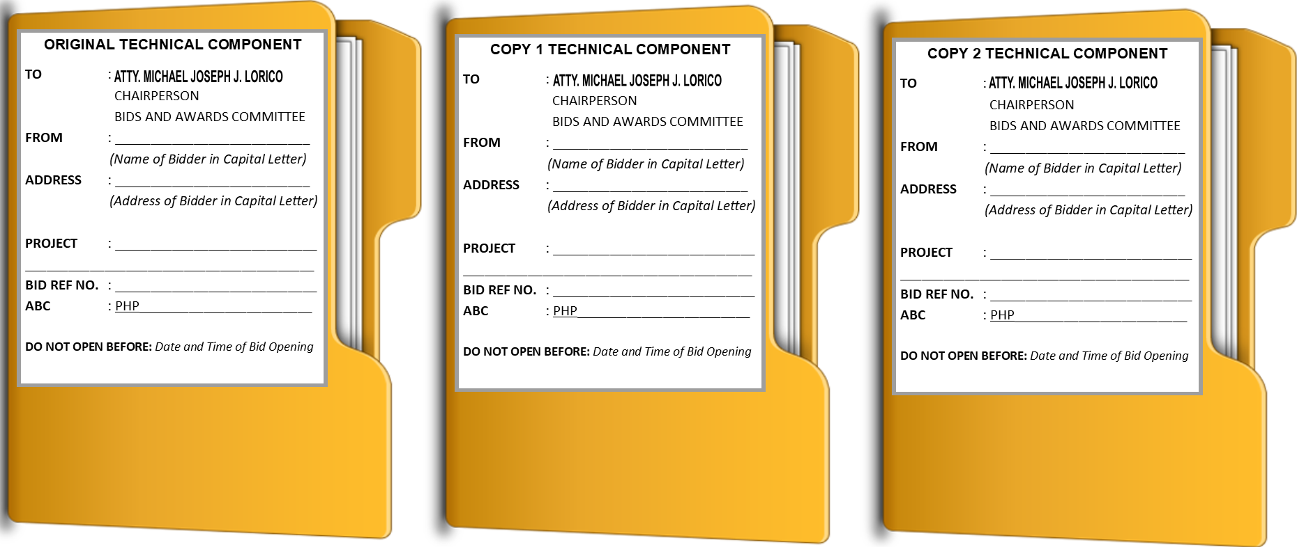

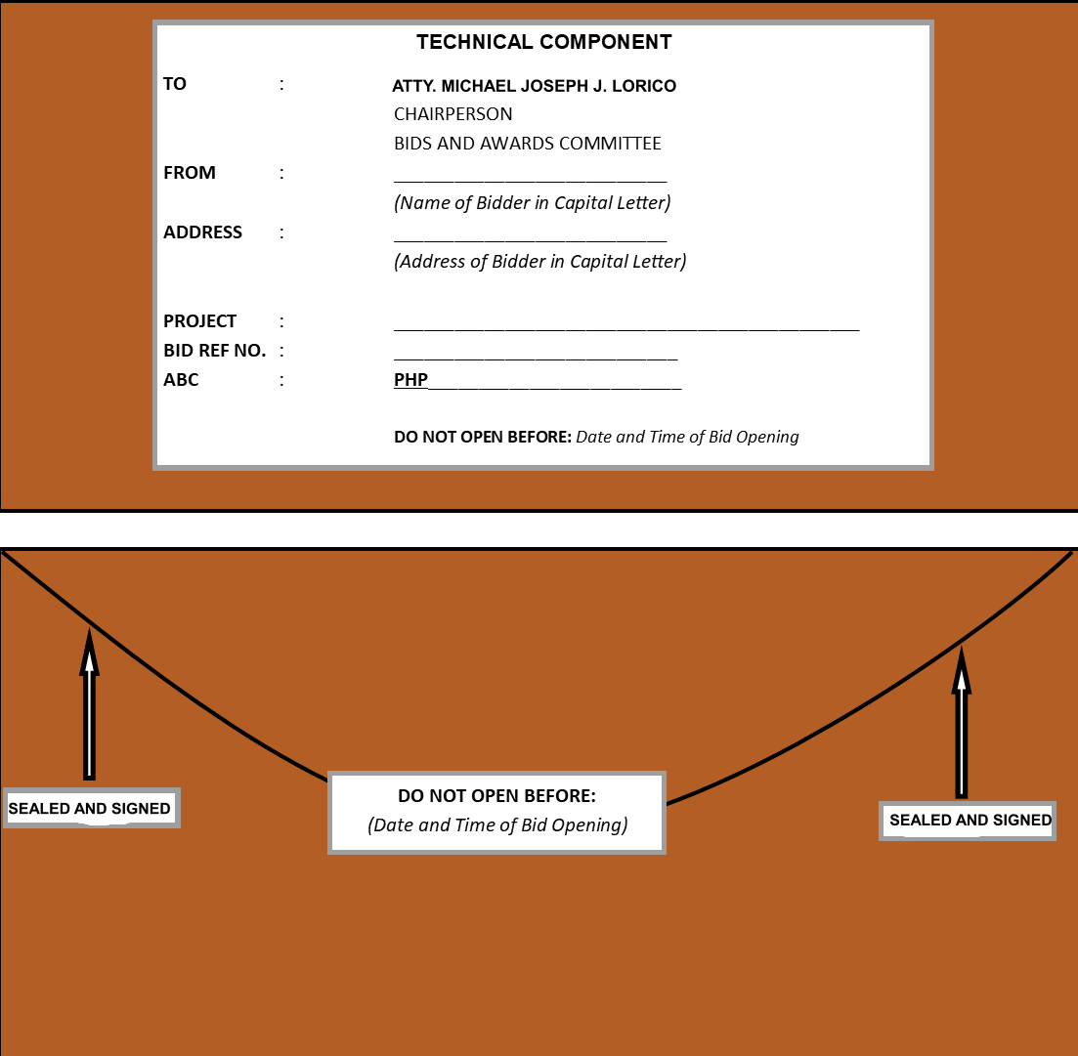
Annex VI-B

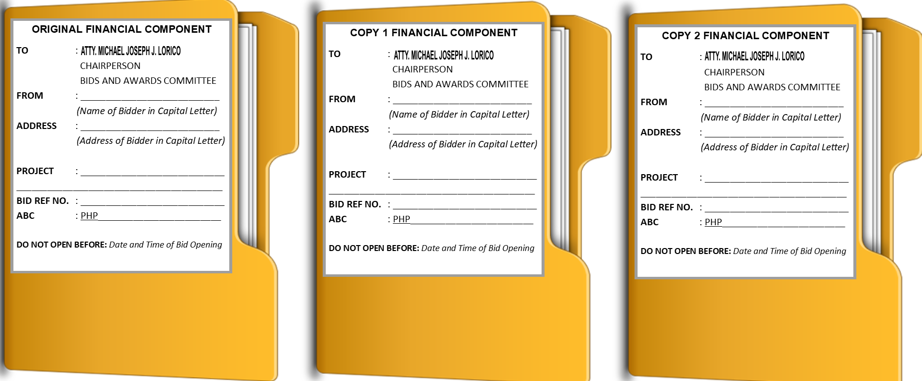
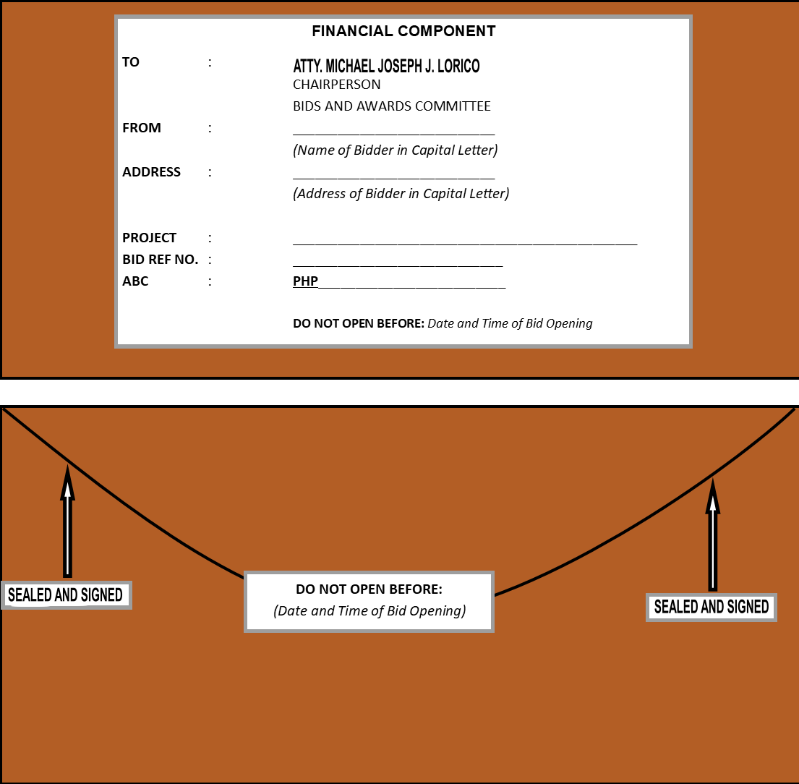

Annex VI - C

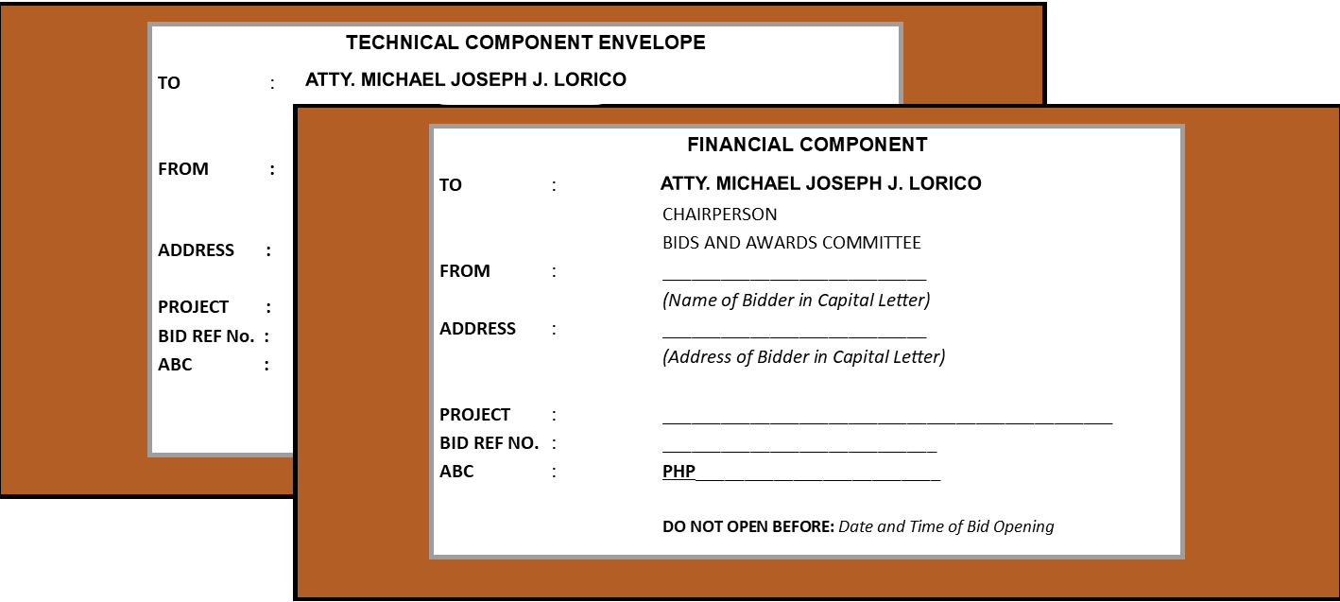
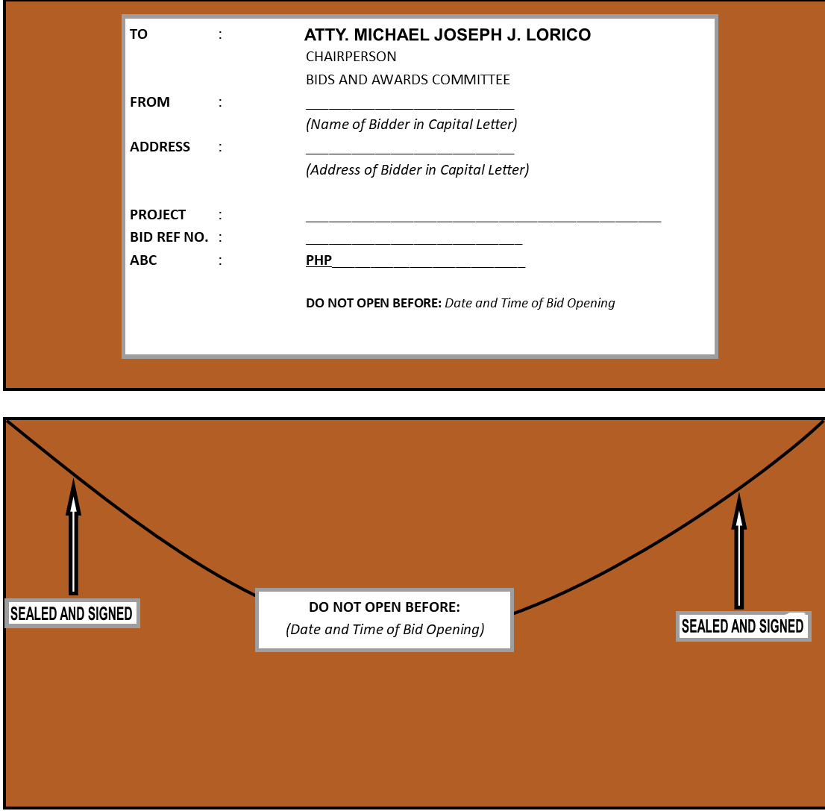

`

In the case of Framework Agreement, the undertaking shall refer to entering into contract with the Procuring Entity and furnishing of the performance security or the performance securing declaration within ten (10) calendar days from receipt of Notice to Execute Framework Agreement.

